**FINAL PROJECT REPORT**

**INFO 5707 Data Modeling**

# **Group-18 - Scholarship Management System**

Team Members Student Id

**Viswak Sena Palaparthi - 11580431**

**Naga Nanda Sai Palanki - 11568649**

**Harsha Vardhan Varma Nagallapati - 11689590**

This Report Presented In Fulfillment of the Requirements for the Master’s Degree in Computer Science.

**Supervised By**

**Tozammel Hossain, PhD**

Professor

Department of Computer Science

University Of North Texas



**University of North Texas**

**Project Description:**

* The "ScholarEase" system is a comprehensive platform designed to revolutionize the management of scholarship programs by government agencies, foundations, and educational institutions.

* Eliminating human inefficiencies, enhancing justice and transparency, and streamlining and speeding up the entire scholarship administration process are the main goals of ScholarEase.Through an easy-to-use user interface, the system offers students a safe and secure online gateway for submitting scholarship applications.

* Extensive eligibility checks predicated on predetermined criteria, like extracurricular activity, financial need, and academic success, are also included. The system provides students with a secure online gateway via which they may easily submit scholarship applications. Comprehensive eligibility checks based on preset standards, such as extracurricular activity, financial need, and academic achievement, are also available through the portal.

* One of ScholarEase's primary objectives is to promote efficient communication and collaboration between stakeholders in the scholarship process.It gives scholarship committees sophisticated review and selection routines so that members can evaluate applications, give applicants points, and choose winners all within the platform.   
  
*In addition, ScholarEase seamlessly integrates with financial aid systems to expedite the distribution of funding and the tracking of expenses, ensuring accurate financial management and compliance with regulatory requirements.Extensive reporting capabilities are another feature of the system that yields insights into recipient demographics, fund utilization, program efficacy, and other areas.   
  
  
* ScholarEase places a high priority on accessibility, providing tools such as keyboard navigation assistance, compatibility with screen readers, and adjustable font sizes and colors to ensure that individuals with disabilities may effectively use and interact with the system.

In conclusion, ScholarEase is an innovative strategy for scholarship management, providing organizations in charge of running scholarship programs with unrivaled accessibility, efficiency, and openness. ScholarEase enables educational institutions to effectively utilize their scholarship programs and substantially enhance the performance of pupils and educational attainment by utilizing cutting-edge technology and comprehensive features.

**Objectives :**

• Revolutionize Efficiency: ScholarEase seeks to do away with manual labor and human error, which are frequently connected to conventional scholarship administration. Administrators can save time and resources as the system streamlines the entire process by automating eligibility checks, selection processes, and application processing.  
• Promote Fairness and Transparency: Automated verification processes and predetermined eligibility requirements guarantee that all applicants are assessed according to the same criteria. This promotes an impartial and open selection process, which raises public confidence in scholarship initiatives.   
  
• Encourage Inclusivity and Accessibility: ScholarEase places a high priority on inclusivity and accessibility by offering an intuitive user interface with features like customizable font sizes and colors, screen reader compatibility, and keyboard navigation. This guarantees that everyone can apply for scholarships without difficulty, even students with disabilities.

• Promote Collaboration and Communication: The platform makes it easier for committees, students, and scholarship providers to communicate with each other. Reviewers can share notes, work together within the system, and assess applications quickly. Administrators can communicate with applicants via secure messaging about deadlines, updates, and award decisions.

• Boost Financial Management and Compliance: ScholarEase works with current financial aid systems to facilitate quicker money distribution and precise tracking of scholarship expenditures. This guarantees appropriate financial administration and compliance with pertinent laws.

• Promote Decisions Driven by Data: The system provides extensive reporting features. Administrators can learn important information about student outcomes, fund utilization, program effectiveness, and recipient demographics. This information can be utilized to measure the program's overall impact on student success, improve resource allocation, and hone selection criteria.

• Optimize Scholarship Program Impact: The ultimate goal of ScholarEase is to provide institutions with the tools they need to strategically use their scholarship programs. The system enables educational institutions to optimize the impact of their scholarships on student achievement and educational attainment by enhancing efficiency, guaranteeing equity, and furnishing valuable data.

Extra Things to Think About: • ScholarEase might also have tools to help with continuing correspondence with scholarship winners. These could be resource directories, tools for tracking progress, or mentoring programs. In order to simplify things, the system might integrate with student information systems.

**Scope :**

**Efficiency and Automation of Systems:**   
  
To minimize human error and reduce manual labor, develop automated processes for eligibility checks, selection processes, and application processing.  
To expedite the entire scholarship administration process—from application submission to fund distribution—implement workflows and algorithms.   
  
**Justice and Openness:**   
  
Establish predefined eligibility requirements and verification procedures to guarantee impartiality and openness in the scholarship recipients' selection.   
Include logging and audit trail features to keep decision-making processes transparent.   
**Accessibility and Inclusivity:**   
  
Create an intuitive user interface that includes modifiable accessibility features like keyboard navigation, color contrasts, screen reader compatibility, and font sizes that can be adjusted.   
To make sure the platform is usable by people with a variety of needs, including those who are disabled, conduct extensive usability testing.

**Working Together and Communicating:**

Provide features that will enable applicants, committee members, scholarship administrators, and providers to collaborate and communicate easily.

Provide secure messaging platforms that applicants and stakeholders can use to receive notifications, updates, and award decisions.

**Compliance and Financial Management:**

Integrate ScholarEase with the current financial aid systems to enable accurate tracking of scholarship expenditures and efficient distribution of funds.

Assure adherence to all applicable laws and rules controlling the administration of scholarships, including those pertaining to data privacy and financial transparency.

**Making Decisions Based on Data:**

Provide comprehensive reporting features to provide insights into recipient demographics, program efficacy, fund utilization, and student outcomes.

Use data analytics tools to examine the gathered information and extract useful information for allocating resources and improving programs.

**Maximizing the Impact of the Scholarship Program:**   
  
Assist institutions in strategically managing their scholarship programs to optimize their influence on student achievement and educational attainment by providing them with tools and resources.  
Provide tools that are integrated with student information systems to facilitate continued communication with scholarship recipients. Examples of these include resource directories, tools for tracking progress, and mentoring programs.   
  
**Scalability and Integration**:   
  
To improve interoperability and streamline administrative procedures, make sure that all current educational systems—such as financial aid platforms and student information systems—integrate seamlessly.   
Create ScholarEase with scalability and adaptability in mind to meet the demands of different-sized and complex educational institutions.   
Instruction and Assistance for Users:   
  
Provide thorough user manuals and training materials to help administrators, committee members, and scholarship applicants become acquainted with the platform.

**Data privacy and security:**   
  
Put strong security measures in place to guard private scholarship information from hackers, illegal access, and data breaches.  
Put in place suitable data encryption, access controls, and privacy policies to guarantee adherence to data privacy laws, such as the CCPA and GDPR.   
  
ScholarEase hopes to transform scholarship administration by upholding this broad scope and fostering effectiveness, equity, inclusivity, and data-driven decision-making while guaranteeing security, compliance, and user satisfaction.

## **Project Requirements**

**Operating System:** Windows or MacOS

**Database:** MySQL

**Applications:** Lucid Chart , Workbench

**Database prerequisites**

Tables used in data base design are

* Student
* Department
* Scholarship
* Faculty
* Report
* Criteria
* Institution
* Application
* Reviewer
* Review
* Reporting Period
* Disbursement
* Disbursement Method
* Award

**User Requirements:**

Those who seek efficiency in administration:   
  
User Requirement: To reduce human error and eliminate manual labor, automate eligibility checks, selection procedures, and application processing.   
User Requirement: Simplify the entire scholarship administration process to save administrators time and resources.   
Advocates for Fairness (Scholarship Committees):   
  
User Requirement: To guarantee that all applicants are evaluated based on the same standards, put automated verification procedures and preset eligibility requirements into place.   
User Requirement: To increase public trust in scholarship programs, encourage equity and openness in the selection process.

Students who support inclusivity, particularly those with disabilities:   
  
User Requirement: To ensure accessibility for all applicants, provide an easy-to-use interface with keyboard navigation, screen reader compatibility, and customizable font sizes and colors.   
Ensure that students with disabilities can easily apply for scholarships. This is a requirement for users.   
Friends of Communication (Students, Committees, Scholarship Providers):   
  
User Requirement: Use features like shared notes, fast application assessment, and secure messaging to promote communication and collaboration between committees, students, and scholarship providers.   
User Requirement: Permit administrators to send applicants critical information via secure messaging about deadlines, updates, and award decisions.

Supervisors and managers of finances:

User Requirement: Connect ScholarEase to current financial aid systems to facilitate quick funding disbursement and guarantee accurate tracking of scholarship expenses.

User Requirement: Make sure that all applicable laws and rules pertaining to financial administration are followed.

Those who make decisions based on data (administrators):

User Requirement: Give administrators access to comprehensive reporting tools so they can learn more about recipient demographics, program efficacy, fund utilization, and student outcomes.

User Requirement: Apply collected data to evaluate the overall effect of the scholarship program on student achievement, enhance the distribution of resources, and enhance the selection process.

Program Enhancers for Academic Institutions:   
  
User Requirement: Give educational institutions the resources they need to strategically use their scholarship programs in order to raise educational attainment and student achievement.   
User Requirement: Maximize the impact of scholarships by guaranteeing equity, improving efficiency, and offering insightful information for choices.   
Providers of Ongoing Support (Mentors, Administrators):   
  
User Requirement: Establish mechanisms, such as resource directories, progress tracking, and mentoring programs, to enable continued communication with scholarship winners.   
User Requirement: Manage and exchange data seamlessly by integrating ScholarEase with student information systems to streamline processes.

**Bussiness Rules:**

Guidelines for Automation:

To cut down on manual labor and human error, eligibility checks, selection procedures, and application processing must all be automated.

Automated processes have to follow specified eligibility criteria and verification steps.

Rules of Fairness and Transparency:

To guarantee impartiality in the selection process, each applicant must be evaluated in accordance with the same pre-established eligibility requirements.

For scholarship programs to remain transparent and trustworthy, automated verification procedures need to be auditable.

The Rules of Inclusivity and Accessibility:

With features like keyboard navigation, screen reader compatibility, and adjustable font sizes and colors, the user interface needs to be made to work with users of all skill levels.

It is imperative to integrate accessibility features into the system to guarantee that students with disabilities can access and navigate it with ease.

Guidelines for Cooperation and Communication:

Committees, students, and scholarship providers must be able to collaborate and communicate easily on the platform.

Reviewers need to be able to work together within the system, exchange notes, and evaluate applications quickly.

Administrators must be able to send applicants critical information about deadlines, updates, and award decisions through secure messaging.

Rules for Financial Management and Compliance:

In order to guarantee precise tracking of scholarship expenditures and speed up fund distribution, ScholarEase needs to be integrated with the current financial aid systems.

Records and financial transactions must abide by all applicable laws and rules pertaining to the administration of scholarships.

Rules for Data Management and Reporting:

Administrators need to be able to access extensive reporting features in the system to obtain information about recipient demographics, program effectiveness, fund utilization, and student outcomes.

Reported and gathered data must be put to use.

Guidelines for Program Optimization:

Educational institutions need to be provided with tools by ScholarEase in order to effectively manage and enhance their scholarship programs.

To optimize the effect of scholarships on student achievement and educational attainment, the system needs to improve efficiency, guarantee equity, and offer useful data for decision-making.

Guidelines for Continued Assistance:

Scholarship winners must have access to resources, progress tracking, mentoring programs, and directories of other resources.

Administrator procedures must be made simpler through integration with student information systems, which also guarantees smooth data management and interchange.

Entity Relationship Diagram (ERD**):**

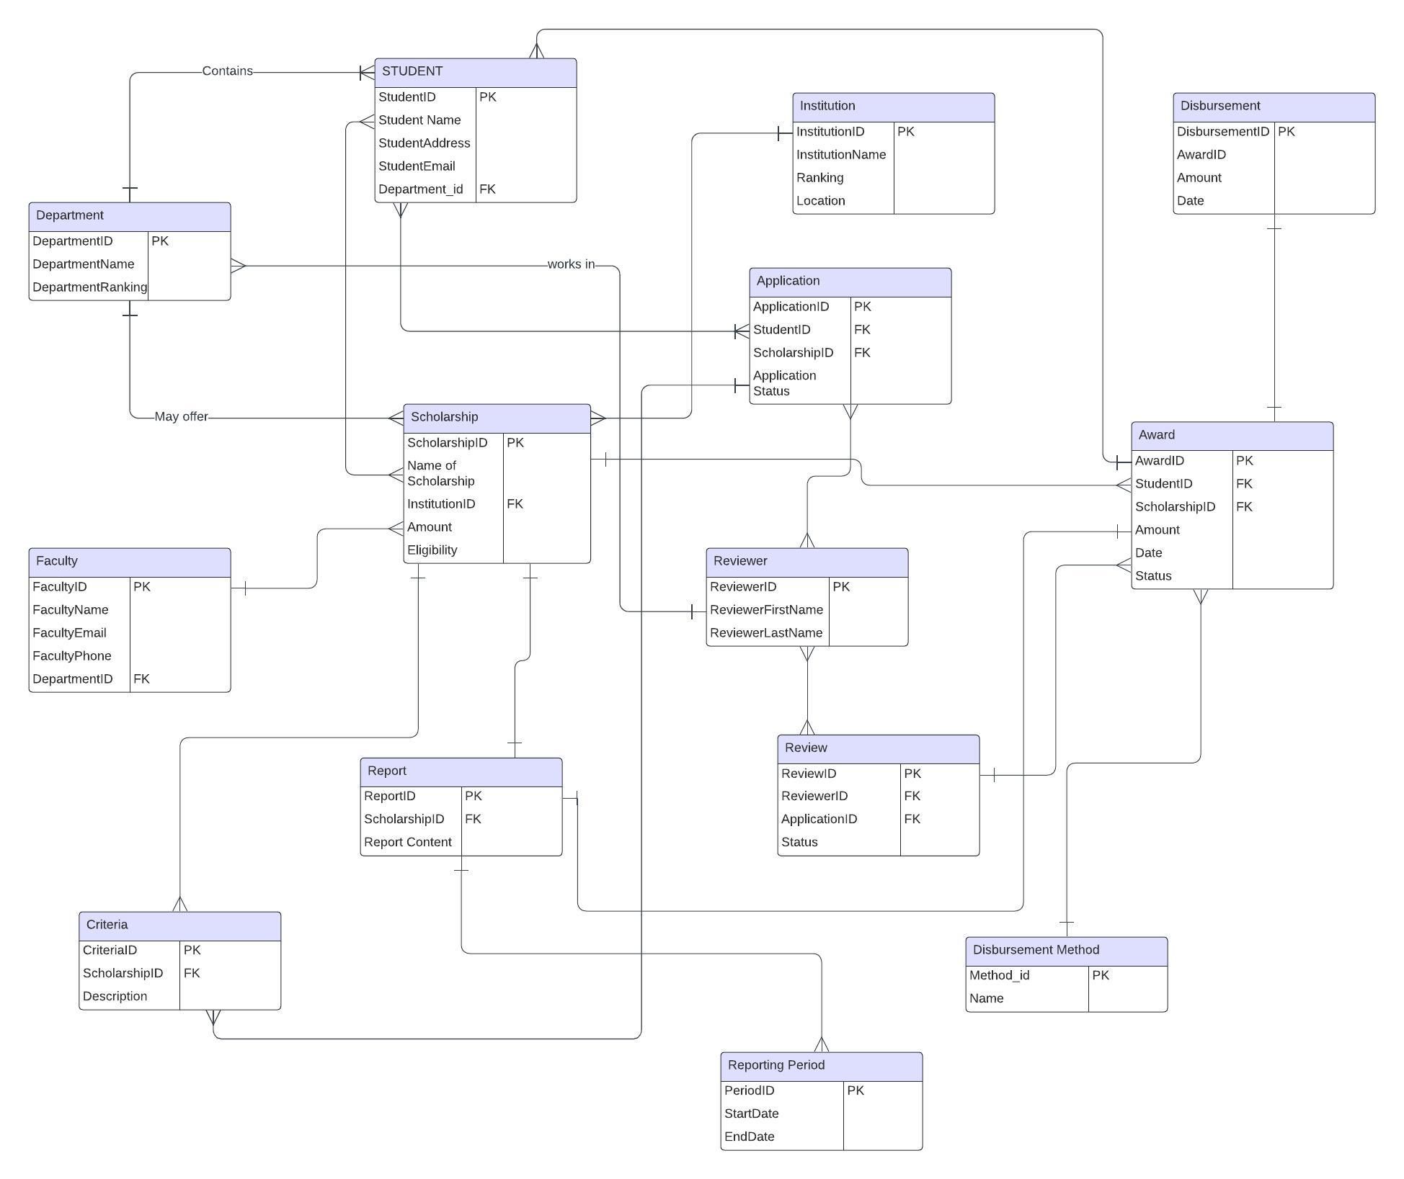

**Relations in above ER-Diagram**

*Student and Department: A student belongs to one department (department_id is a foreign key referencing departmentID in the Department table).

*Student and Scholarship: A student can be awarded many scholarships (StudentID is a foreign key referencing scholarshipID in the Scholarship table).

*Scholarship and Award: A scholarship can have one type of award (awardID is a foreign key referencing AwardID in the Award table).

* Scholarship and Institution : A scholarship is offered by one institution (institutionID is a foreign key referencing InstitutionID in the Institution table).

* Scholarship and Criteria: A scholarship can have many criteria (scholarshipID is a foreign key referencing scholarshipID in the Criteria table).

*Scholarship and Application: A scholarship can have many applications (scholarshipID is a foreign key referencing scholarshipID in the Application table).

* Application and Student: An application is submitted by one student (studentID is a foreign key referencing StudentID in the Student table).

* Application and Review: An application can have many reviews (applicationID is a foreign key referencing reviewID in the Review table).

* Review and Faculty: A review is written by one faculty member (reviewerID is a foreign key referencing facultyID in the Faculty table).

* Review and Scholarship: A review is for one scholarship (scholarshipID is a foreign key referencing scholarshipID in the Scholarship table).

*Department and Faculty: A faculty member works in one department (departmentID is a foreign key referencing departmentID in the Department table).

*Disbursement and Student: A disbursement is made to one student (studentID is a foreign key referencing studentID in the Student table).

* Disbursement and Criteria: A disbursement is based on meeting certain criteria (criteriaID is a foreign key referencing criteriaID in the Criteria table).

**Data Dictionary:**

|  |  |  |  |  |  |  |  |  |
| --- | --- | --- | --- | --- | --- | --- | --- | --- |
| SNo | Table Name | Attribute Name | Description | Data Type | Format | Range | PK/FK | FK Table |
| 1 | Student | StudentID | Unique identifier for a student | Integer |  |  | PK |  |
| 2 | Student | StudentName | Name of the student | String |  |  |  |  |
| 3 | Student | StudentAddress | Student’s address | String |  |  |  |  |
| 4 | Student | StudentEmail | Student’s email address | String |  |  |  |  |
| 5 | Student | DepartmentID | Foreign key referencing departmentID in the Department table | Integer |  |  | FK | Department |
| 6 | Department | DepartmentID | Unique identifier for a department | Integer |  |  | PK |  |
| 7 | Department | DepartmentName | Name of the department | String |  |  |  |  |
| 8 | Department | Location | Location of the department | String |  |  |  |  |
| 9 | Institution | InstitutionID | Unique identifier for an institution | Integer |  |  | PK |  |
| 10 | Institution | InstitutionName | Name of the institution | String |  |  |  |  |
| 11 | Award | AwardID | Unique identifier for an award type | Integer |  |  | PK |  |
| 12 | Award | Name | Name of the award | String |  |  |  |  |
| 13 | Scholarship | ScholarshipID | Unique identifier for a scholarship | Integer |  |  | PK |  |
| 14 | Scholarship | AwardID | Foreign key referencing AwardID in the Award table | Integer |  |  | FK | Award |
| 15 | Scholarship | InstitutionID | Foreign key referencing InstitutionID in the Institution table | Integer |  |  | FK | Institution |
| 16 | Scholarship | Amount | Amount of the scholarship | Decimal |  |  |  |  |
| 17 | Application | ApplicationID | Unique identifier for an application | Integer |  |  | PK |  |
| 18 | Application | StudentID | Foreign key referencing StudentID in the Student table | Integer |  |  | FK | Student |
| 19 | Application | ScholarshipID | Foreign key referencing ScholarshipID in the Scholarship table | Integer |  |  | FK | Scholarship |
| 20 | Application | ApplicationStatus | Status of the application (e.g., pending, approved, rejected) | String |  |  |  |  |
| 21 | Faculty | FacultyID | Unique identifier for a faculty member | Integer |  |  | PK |  |
| 22 | Faculty | FacultyName | Name of the faculty member | String |  |  |  |  |
| 23 | Faculty | FacultyEmail | Faculty member’s email address | String |  |  |  |  |
| 24 | Faculty | FacultyPhone | Faculty member’s phone number | String |  |  |  |  |
| 25 | Faculty | DepartmentID | Foreign key referencing DepartmentID in the Department table | Integer |  |  | FK | Department |
| 26 | Review | ReviewID | Unique identifier for a review | Integer |  |  | PK |  |
| 27 | Review | ScholarshipID | Foreign key referencing ScholarshipID in the Scholarship table | Integer |  |  | FK | Scholarship |
| 28 | Review | ApplicationID | Foreign key referencing ApplicationID in the Application table | Integer |  |  | FK | Application |
| 29 | Review | ReviewerID | Foreign key referencing FacultyID in the Faculty table | Integer |  |  | FK | Faculty |
| 30 | Review | ReportContent | Content of the review report | String |  |  |  |  |
| 31 | Review | Status | Status of the review (e.g., submitted, | String |  |  |  |  |
| 32 | Criteria | CriteriaID | Unique identifier for scholarship criteria | Integer |  |  | PK |  |
| 33 | Criteria | ScholarshipID | Foreign key referencing ScholarshipID in the Scholarship table | Integer |  |  | FK | Scholarship |
| 34 | Criteria | Description | Description of the scholarship criteria | String |  |  |  |  |
| 35 | Disbursement | DisbursementID | Unique identifier for a disbursement | Integer |  |  | PK |  |
| 36 | Disbursement | StudentID | Foreign key referencing StudentID in the Student table | Integer |  |  | FK | Student |
| 37 | Disbursement | CriteriaID | Foreign key referencing CriteriaID in the Criteria table | Integer |  |  | FK | Criteria |
| 38 | Disbursement | MethodID | Foreign key referencing methodID in the Method table (not shown) |  |  |  |  |  |

### **Section 2: Queries and Results**

**Department table**:

CREATE TABLE IF NOT EXISTS Department (

DepartmentID INT AUTO_INCREMENT PRIMARY KEY,

DepartmentName VARCHAR(100),

Location VARCHAR(100)

);

**Faculty table :**

CREATE TABLE IF NOT EXISTS Faculty (

FacultyID INT AUTO_INCREMENT PRIMARY KEY,

FacultyName VARCHAR(100),

FacultyEmail VARCHAR(100),

FacultyPhone VARCHAR(20),

DepartmentID INT,

FOREIGN KEY (DepartmentID) REFERENCES Department(DepartmentID)

);

**Report table:**

CREATE TABLE IF NOT EXISTS Report (

ReportID INT AUTO_INCREMENT PRIMARY KEY,

ReportContent TEXT,

Status VARCHAR(50)

);

**Reviewer table :**

CREATE TABLE IF NOT EXISTS Reviewer (

ReviewerID INT AUTO_INCREMENT PRIMARY KEY,

ReviewerName VARCHAR(100),

ReviewerEmail VARCHAR(100)

);

**ReportingPeriod table:**

CREATE TABLE IF NOT EXISTS ReportingPeriod (

ReportingPeriodID INT AUTO_INCREMENT PRIMARY KEY,

PeriodStart DATE,

PeriodEnd DATE

);

**DisbursementMethod table:**

CREATE TABLE IF NOT EXISTS DisbursementMethod (

MethodID INT AUTO_INCREMENT PRIMARY KEY,

MethodName VARCHAR(100)

);

**Award table:**

CREATE TABLE IF NOT EXISTS Award (

AwardID INT AUTO_INCREMENT PRIMARY KEY,

Name VARCHAR(100)

);

**Institution table :**

CREATE TABLE IF NOT EXISTS Institution (

InstitutionID INT AUTO_INCREMENT PRIMARY KEY,

InstitutionName VARCHAR(100)

);

**Student table:**

CREATE TABLE IF NOT EXISTS Student (

StudentID INT AUTO_INCREMENT PRIMARY KEY,

StudentName VARCHAR(100),

StudentAddress VARCHAR(200),

StudentEmail VARCHAR(100),

DepartmentID INT,

FOREIGN KEY (DepartmentID) REFERENCES Department(DepartmentID)

);

**Scholarship:**

CREATE TABLE IF NOT EXISTS Scholarship (

ScholarshipID INT AUTO_INCREMENT PRIMARY KEY,

AwardID INT,

InstitutionID INT,

Amount DECIMAL(10, 2),

FOREIGN KEY (AwardID) REFERENCES Award(AwardID),

FOREIGN KEY (InstitutionID) REFERENCES Institution(InstitutionID)

);

**Application table:**

CREATE TABLE IF NOT EXISTS Application (

ApplicationID INT AUTO_INCREMENT PRIMARY KEY,

StudentID INT,

ScholarshipID INT,

ApplicationStatus VARCHAR(50),

FOREIGN KEY (StudentID) REFERENCES Student(StudentID),

FOREIGN KEY (ScholarshipID) REFERENCES Scholarship(ScholarshipID)

);

**Criteria table:**

CREATE TABLE IF NOT EXISTS Criteria (

CriteriaID INT AUTO_INCREMENT PRIMARY KEY,

ScholarshipID INT,

Description TEXT,

FOREIGN KEY (ScholarshipID) REFERENCES Scholarship(ScholarshipID)

);

**Review table:**

CREATE TABLE IF NOT EXISTS Review (

ReviewID INT AUTO_INCREMENT PRIMARY KEY,

ScholarshipID INT,

ApplicationID INT,

ReviewerID INT,

ReportID INT,

Status VARCHAR(50),

FOREIGN KEY (ScholarshipID) REFERENCES Scholarship(ScholarshipID),

FOREIGN KEY (ApplicationID) REFERENCES Application(ApplicationID),

FOREIGN KEY (ReviewerID) REFERENCES Reviewer(ReviewerID),

FOREIGN KEY (ReportID) REFERENCES Report(ReportID)

);

**Disbursement table:**

CREATE TABLE IF NOT EXISTS Disbursement (

DisbursementID INT AUTO_INCREMENT PRIMARY KEY,

StudentID INT,

CriteriaID INT,

Amount DECIMAL(10, 2),

ReportingPeriodID INT,

FOREIGN KEY (StudentID) REFERENCES Student(StudentID),

FOREIGN KEY (CriteriaID) REFERENCES Criteria(CriteriaID),

);

**Screenshots for table creation :**

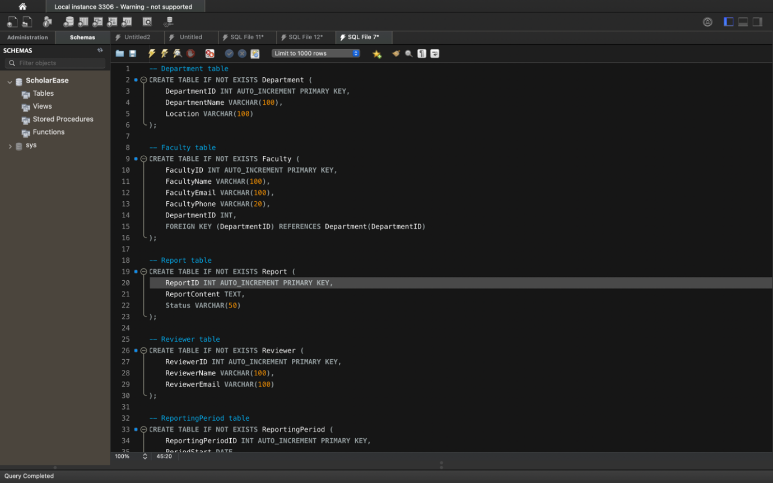

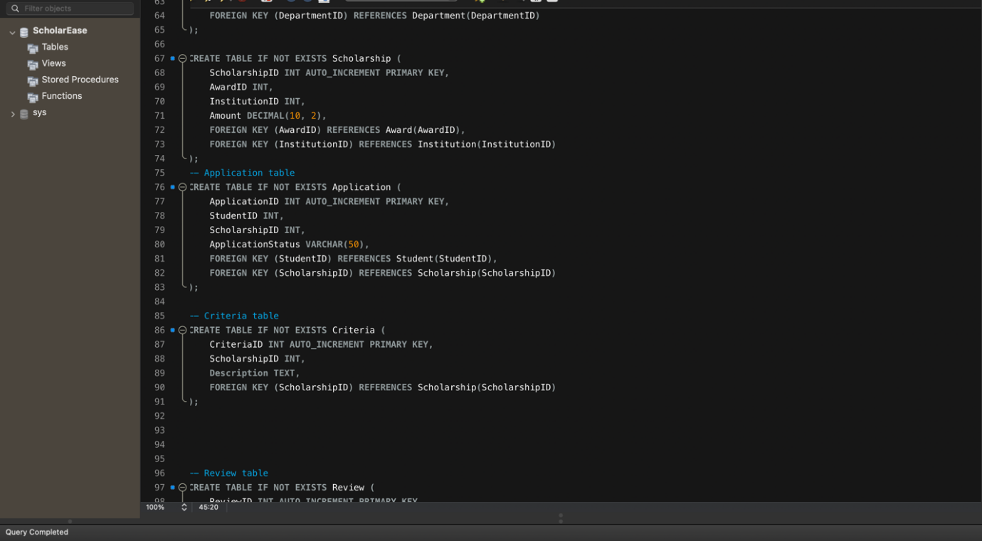

**Inserting Data into Each table:**

INSERT INTO Department (DepartmentName, Location)

VALUES

('Computer Science', 'Science Building'),

('Engineering', 'Engineering Building'),

('Mathematics', 'Mathematics Building'),

('Physics', 'Physics Building'),

('Chemistry', 'Chemistry Building'),

('Biology', 'Biology Building'),

('English', 'English Building'),

('History', 'History Building'),

('Psychology', 'Psychology Building'),

('Sociology', 'Sociology Building'),

('Economics', 'Economics Building'),

('Business Administration', 'Business Building'),

('Music', 'Music Building'),

('Art', 'Art Building'),

('Theatre Arts', 'Theatre Building'),

('Dance', 'Dance Building'),

('Education', 'Education Building'),

('Kinesiology', 'Kinesiology Building'),

('Health Sciences', 'Health Sciences Building'),

('Information Science', 'Information Science Building'),

('Library Science', 'Library Science Building'),

('Political Science', 'Political Science Building'),

('Communication Studies', 'Communication Building'),

('Geography', 'Geography Building'),

('Philosophy', 'Philosophy Building'),

('Religious Studies', 'Religious Studies Building'),

('Public Administration', 'Public Administration Building'),

('Nutrition', 'Nutrition Building'),

('Environmental Science', 'Environmental Science Building');

Department Table

Displaying the Data:

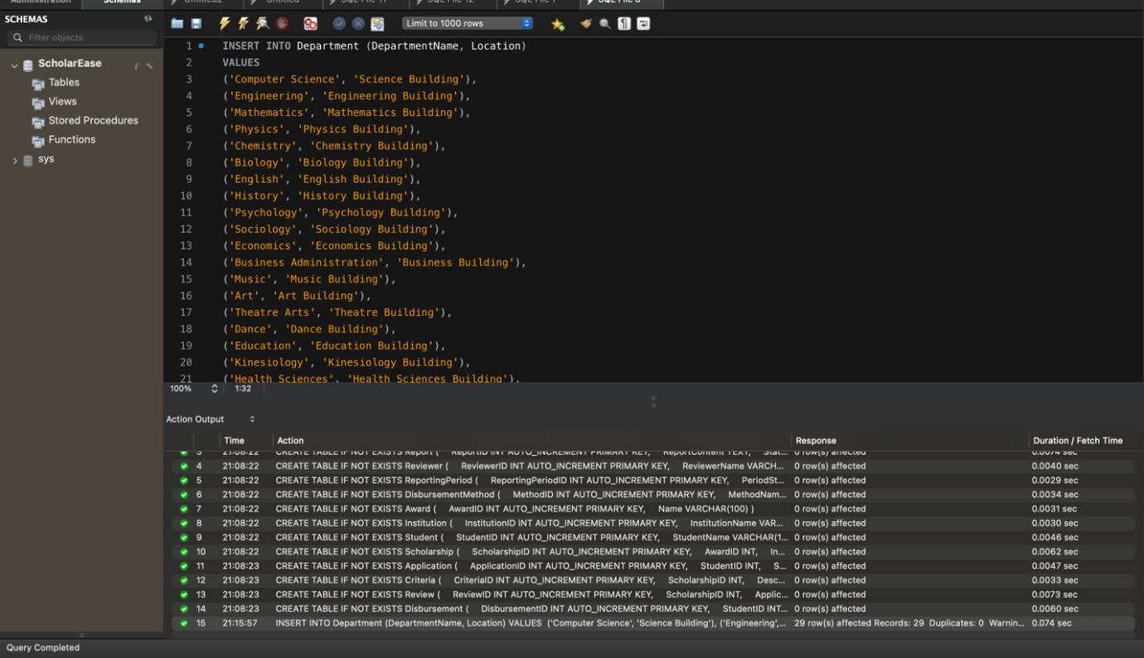

Faculty Table:

INSERT INTO Faculty (FacultyName, FacultyEmail, FacultyPhone, DepartmentID)

VALUES

('John Smith', 'jsmith@unt.edu', '123-456-7890', 1),

('Emily Johnson', 'ejohnson@unt.edu', '234-567-8901', 1),

('Michael Williams', 'mwilliams@unt.edu', '345-678-9012', 2),

('Jessica Brown', 'jbrown@unt.edu', '456-789-0123', 2),

('David Jones', 'djones@unt.edu', '567-890-1234', 3),

('Jennifer Davis', 'jdavis@unt.edu', '678-901-2345', 3),

('Christopher Miller', 'cmiller@unt.edu', '789-012-3456', 4),

('Sarah Wilson', 'swilson@unt.edu', '890-123-4567', 4),

('Matthew Moore', 'mmoore@unt.edu', '901-234-5678', 5),

('Amanda Taylor', 'ataylor@unt.edu', '012-345-6789', 5),

('Robert Anderson', 'randerson@unt.edu', '123-456-7890', 6),

('Stephanie Martinez', 'smartinez@unt.edu', '234-567-8901', 6),

('William Jackson', 'wjackson@unt.edu', '345-678-9012', 7),

('Lauren White', 'lwhite@unt.edu', '456-789-0123', 7),

('Daniel Harris', 'dharris@unt.edu', '567-890-1234', 8),

('Karen Thompson', 'kthompson@unt.edu', '678-901-2345', 8),

('Richard Garcia', 'rgarcia@unt.edu', '789-012-3456', 9),

('Ashley Martinez', 'amartinez@unt.edu', '890-123-4567', 9),

('James Robinson', 'jrobinson@unt.edu', '901-234-5678', 10),

('Melissa Lee', 'mlee@unt.edu', '012-345-6789', 10),

('Daniel Clark', 'dclark@unt.edu', '123-456-7890', 11),

('Rebecca Wright', 'rwright@unt.edu', '234-567-8901', 11),

('Jonathan King', 'jking@unt.edu', '345-678-9012', 12),

('Rachel Scott', 'rscott@unt.edu', '456-789-0123', 12),

('Justin Adams', 'jadams@unt.edu', '567-890-1234', 13),

('Natalie Hill', 'nhill@unt.edu', '678-901-2345', 13),

('Brandon Young', 'byoung@unt.edu', '789-012-3456', 14),

('Kelly Rodriguez', 'krodriguez@unt.edu', '890-123-4567', 14),

('Erica Martinez', 'emartinez@unt.edu', '901-234-5678', 15),

('Timothy Hall', 'thall@unt.edu', '012-345-6789', 15);

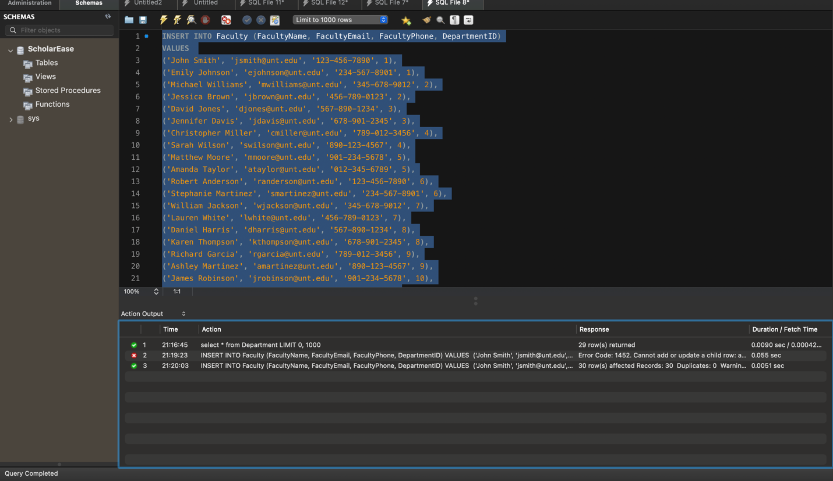

Displaying the data:

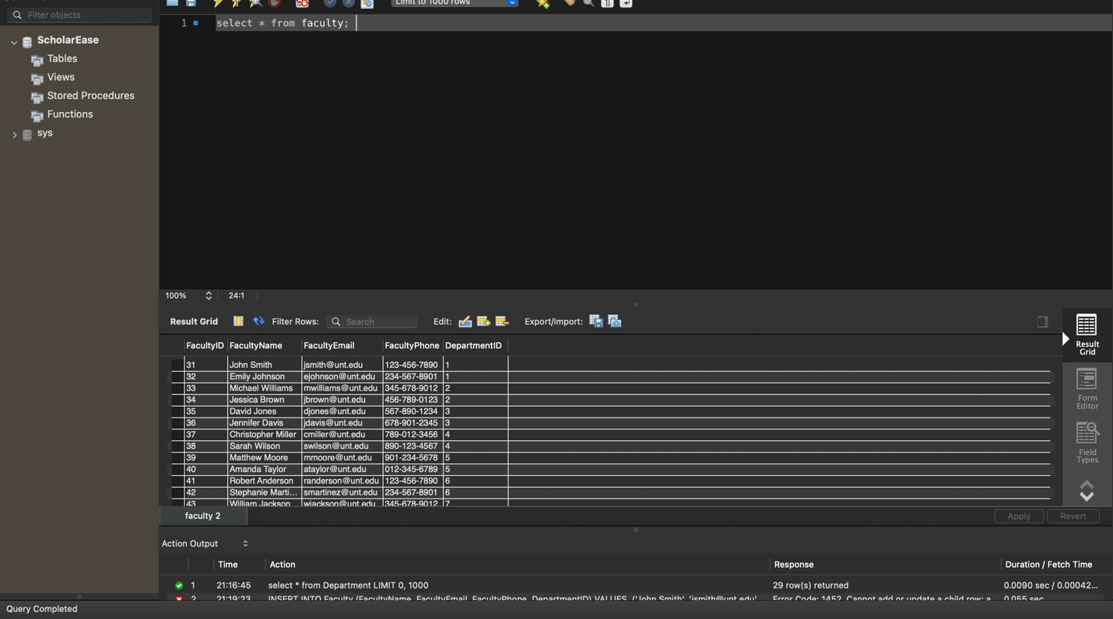

**Report:**

INSERT INTO Report (ReportContent, Status) VALUES

('The scholarship application has been reviewed and meets all criteria.', 'Approved'),

('Additional documentation is required to process the scholarship application.', 'Pending'),

('The scholarship committee has identified the recipient based on academic merit.', 'Approved'),

('A decision on the scholarship application is pending further review.', 'Pending'),

('The scholarship interview process has been completed successfully.', 'Approved'),

('The scholarship funds have been disbursed to the recipient.', 'Approved'),

('The scholarship application deadline has been extended due to unforeseen circumstances.', 'Pending'),

('The scholarship selection process is underway, and applicants will be notified soon.', 'Pending'),

('An error in the scholarship application has been identified and corrected.', 'Pending'),

('The scholarship recipient has been notified and is required to submit acceptance documentation.', 'Pending'),

('The scholarship committee is reviewing applications for financial need-based awards.', 'Approved'),

('Scholarship recipients will be announced at the upcoming awards ceremony.', 'Pending'),

('The scholarship essay submissions demonstrate creativity and originality.', 'Approved'),

('The scholarship application review process is proceeding as planned.', 'Pending'),

('The scholarship committee is evaluating candidates for the leadership scholarship.', 'Approved'),

('The scholarship application portal is temporarily unavailable due to system maintenance.', 'Pending'),

('Scholarship eligibility criteria have been updated to reflect changes in funding.', 'Approved'),

('The scholarship application pool has been narrowed down to final candidates for consideration.', 'Pending'),

('The scholarship award amount has been adjusted to ensure equitable distribution.', 'Approved'),

('The scholarship selection process has been delayed due to unforeseen circumstances.', 'Pending'),

('The scholarship recipient has provided proof of enrollment and eligibility.', 'Approved'),

('The scholarship committee is reviewing applications for academic achievement awards.', 'Pending'),

('Scholarship disbursement has been delayed pending final approval from the funding source.', 'Pending'),

('The scholarship recipient has been selected based on demonstrated financial need.', 'Approved'),

('The scholarship application review process has been completed ahead of schedule.', 'Approved'),

('The scholarship recipient has been chosen based on their commitment to community service.', 'Approved'),

('The scholarship committee is evaluating candidates for the STEM scholarship.', 'Pending'),

('Scholarship recipients are required to attend an orientation session prior to disbursement.', 'Pending'),

('The scholarship application portal has been updated with additional resources for applicants.', 'Approved'),

('The scholarship committee is reviewing applications for the need-based scholarship.', 'Pending');

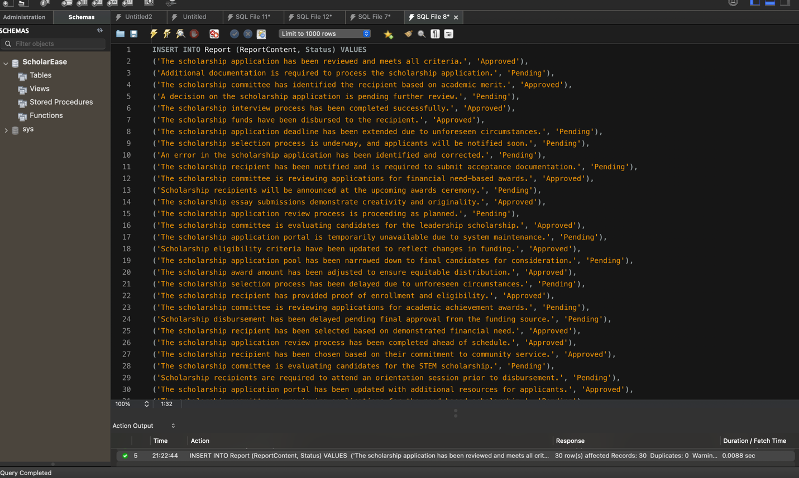

Displaying the Data:

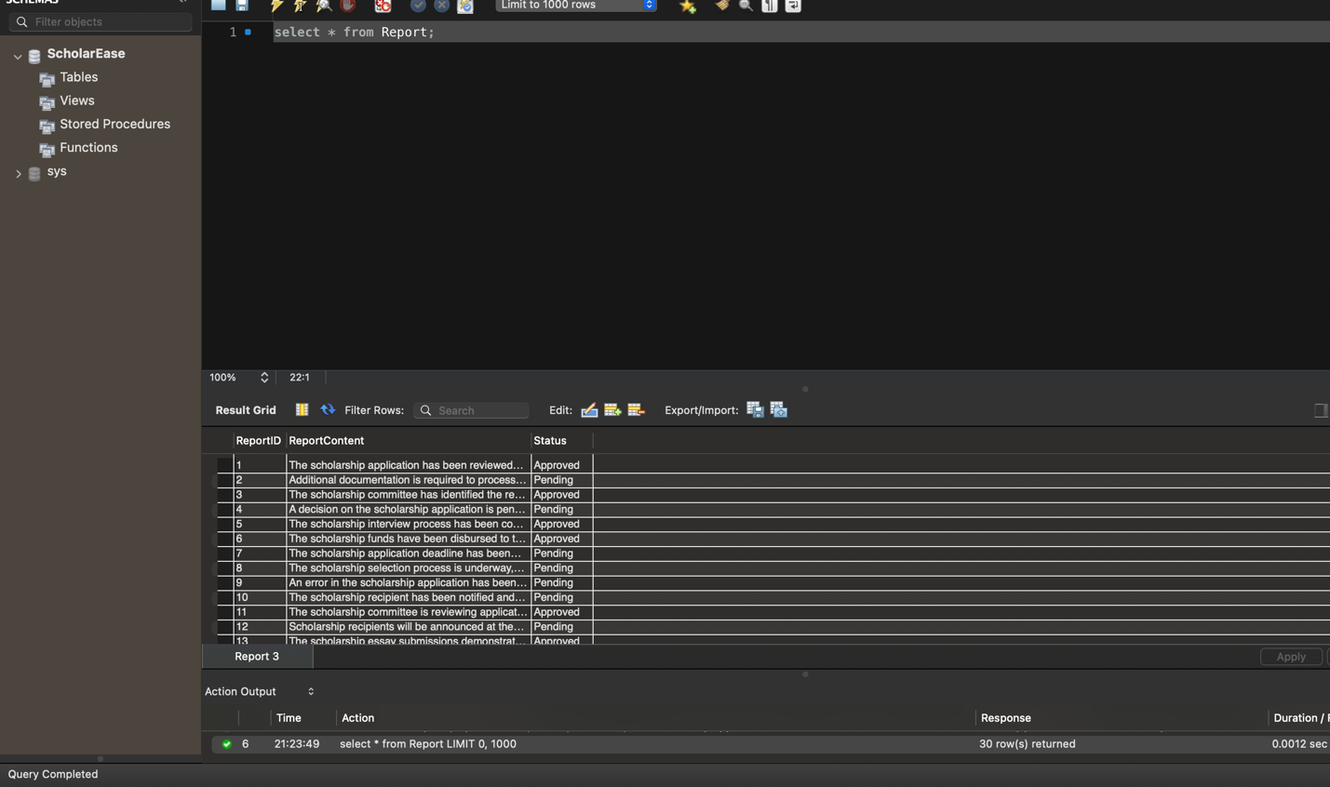

Reviewer Table : INSERT INTO Reviewer (ReviewerName, ReviewerEmail) VALUES

('John Smith', 'john.smith@example.com'),

('Emily Johnson', 'emily.johnson@example.com'),

('Michael Brown', 'michael.brown@example.com'),

('Jessica Davis', 'jessica.davis@example.com'),

('Christopher Wilson', 'christopher.wilson@example.com'),

('Jennifer Taylor', 'jennifer.taylor@example.com'),

('Matthew Martinez', 'matthew.martinez@example.com'),

('Amanda Anderson', 'amanda.anderson@example.com'),

('Daniel Thomas', 'daniel.thomas@example.com'),

('Sarah Garcia', 'sarah.garcia@example.com'),

('Robert Rodriguez', 'robert.rodriguez@example.com'),

('Melissa Martinez', 'melissa.martinez@example.com'),

('David Hernandez', 'david.hernandez@example.com'),

('Jennifer Wright', 'jennifer.wright@example.com'),

('Brian Lopez', 'brian.lopez@example.com'),

('Jessica Hill', 'jessica.hill@example.com'),

('William Young', 'william.young@example.com'),

('Laura Lee', 'laura.lee@example.com'),

('Kevin Scott', 'kevin.scott@example.com'),

('Maria King', 'maria.king@example.com'),

('James Campbell', 'james.campbell@example.com'),

('Mary Hall', 'mary.hall@example.com'),

('Richard Green', 'richard.green@example.com'),

('Stephanie Baker', 'stephanie.baker@example.com'),

('Andrew Perez', 'andrew.perez@example.com'),

('Patricia Adams', 'patricia.adams@example.com'),

('Mark Evans', 'mark.evans@example.com'),

('Jennifer Torres', 'jennifer.torres@example.com'),

('Jason Morris', 'jason.morris@example.com');

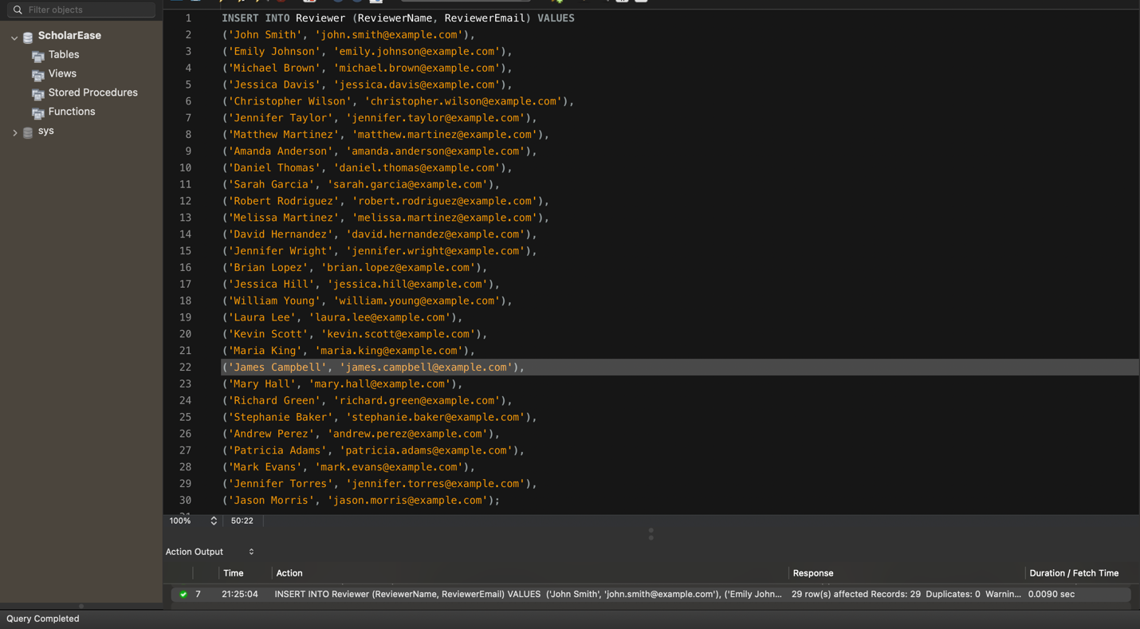

Displaying the data:

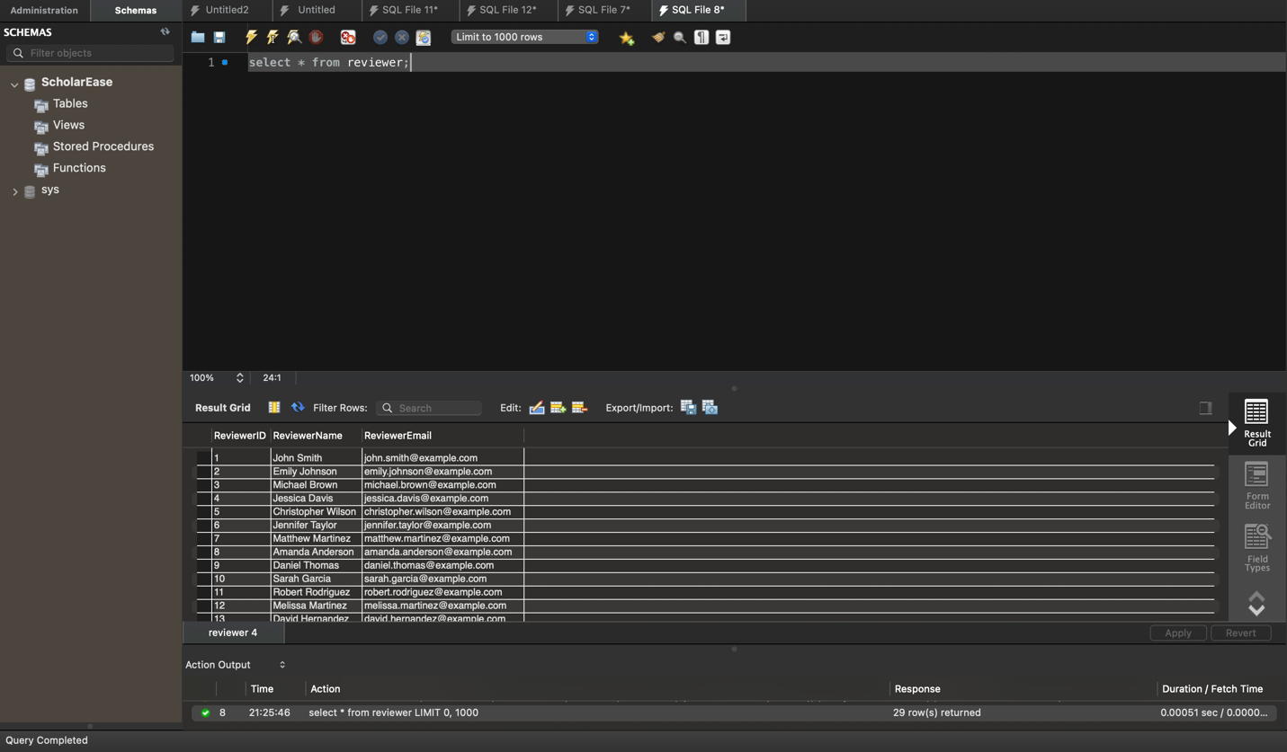

Reporting Period : INSERT INTO ReportingPeriod (PeriodStart, PeriodEnd) VALUES

('2020-01-01', '2020-05-15'), -- Spring 2020

('2020-05-16', '2020-08-15'), -- Summer 2020

('2020-08-16', '2020-12-31'), -- Fall 2020

('2021-01-01', '2021-05-15'), -- Spring 2021

('2021-05-16', '2021-08-15'), -- Summer 2021

('2021-08-16', '2021-12-31'), -- Fall 2021

('2022-01-01', '2022-05-15'), -- Spring 2022

('2022-05-16', '2022-08-15'), -- Summer 2022

('2022-08-16', '2022-12-31'), -- Fall 2022

('2023-01-01', '2023-05-15'), -- Spring 2023

('2023-05-16', '2023-08-15'), -- Summer 2023

('2023-08-16', '2023-12-31'), -- Fall 2023

('2024-01-01', '2024-05-15'), -- Spring 2024

('2024-05-16', '2024-08-15'), -- Summer 2024

('2024-08-16', '2024-12-31'); -- Fall 2024

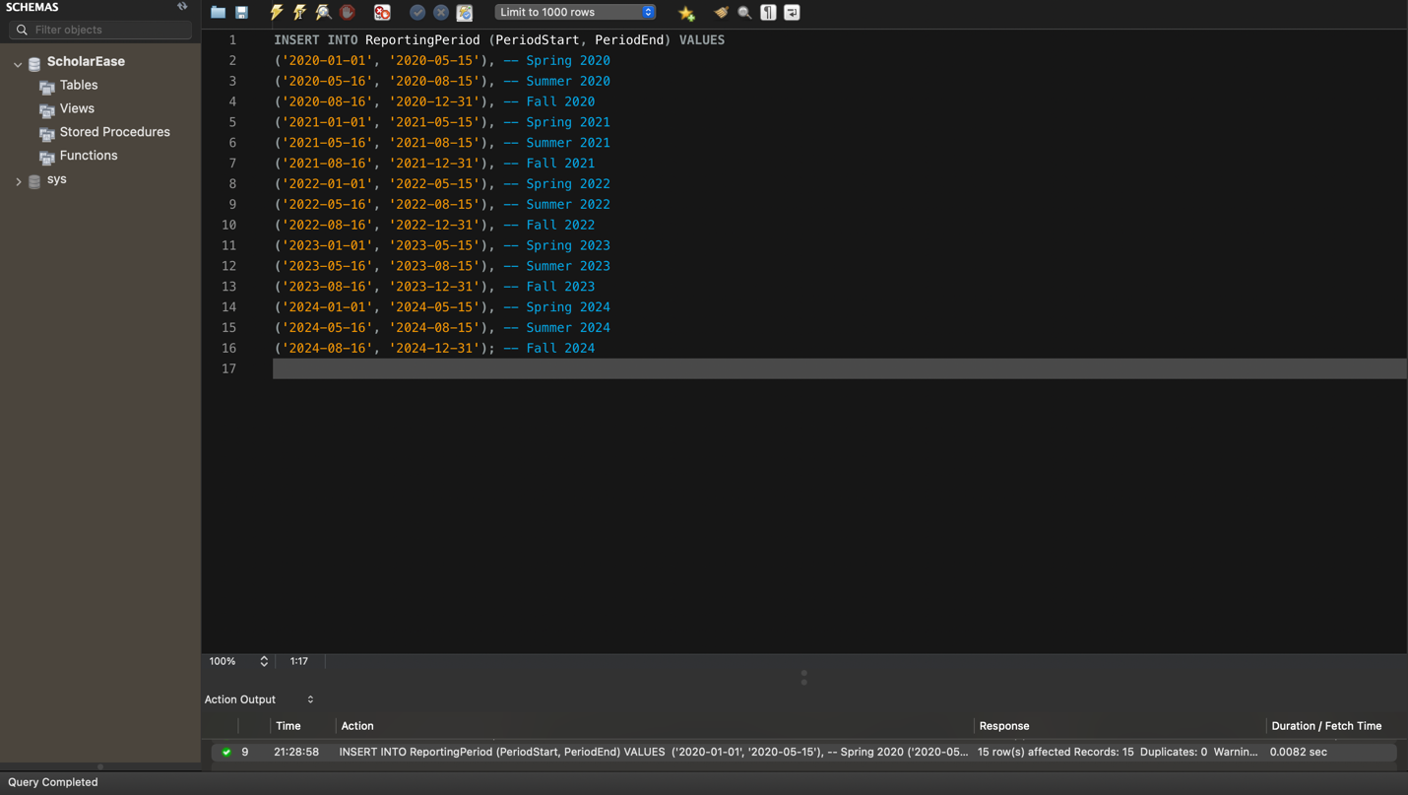

Displaying the data :

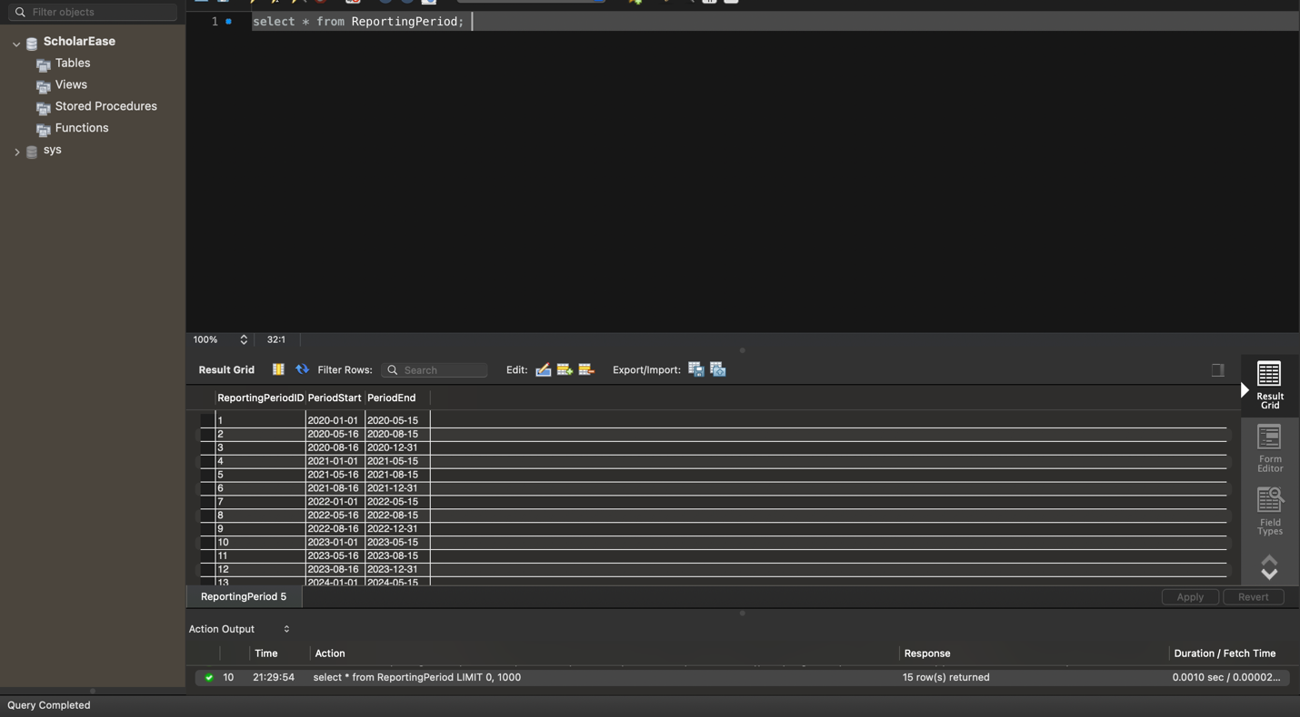

Disbursement Method: INSERT INTO DisbursementMethod (MethodName) VALUES

('Direct Deposit'),

('Check'),

('Bank Transfer'),

('Cash'),

('PayPal'),

('Wire Transfer'),

('Venmo'),

('Cash App'),

('Zelle'),

('Money Order');

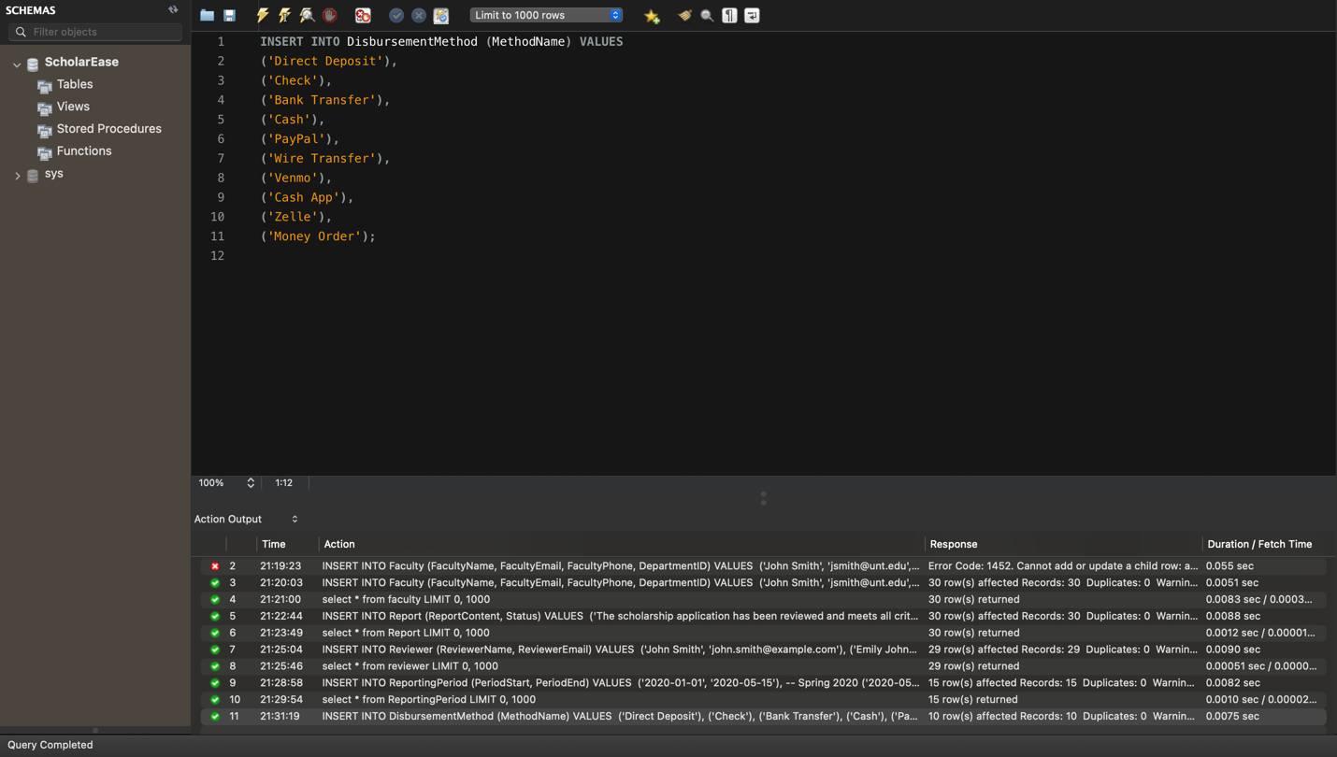

Displaying the data :

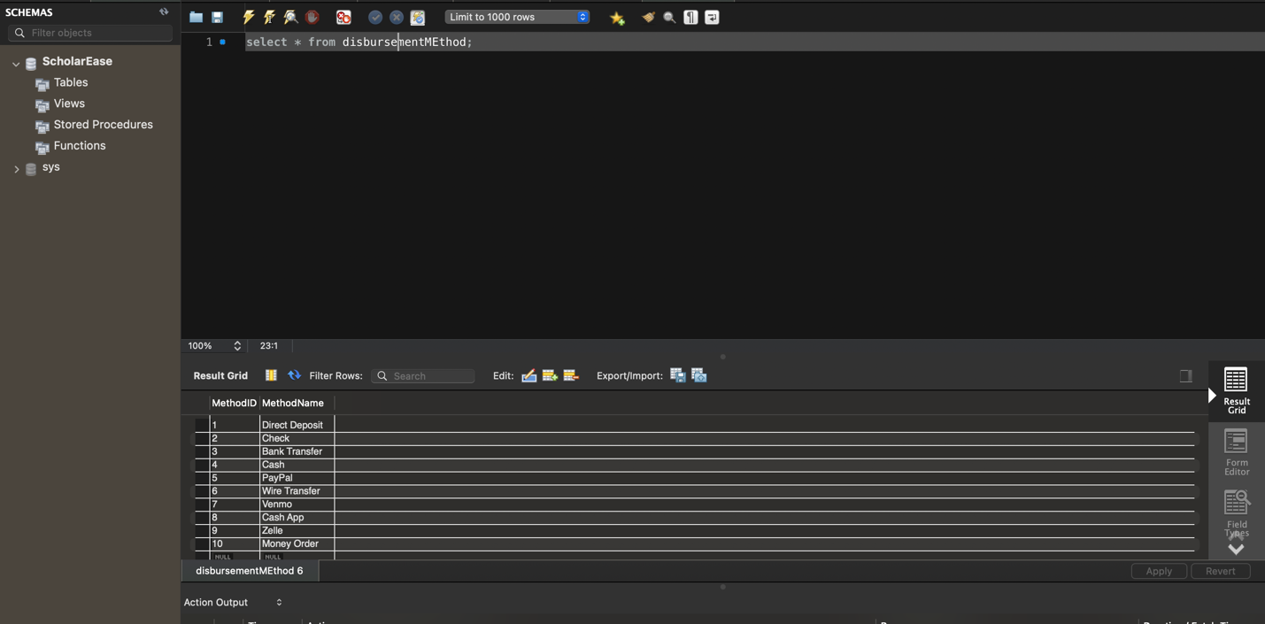

Award Table: INSERT INTO Award (Name) VALUES

('Merit Scholarship'),

('Need-Based Scholarship'),

('STEM Scholarship'),

('Athletic Scholarship'),

('Fine Arts Scholarship'),

('Leadership Scholarship'),

('Community Service Scholarship'),

('First-Generation Scholarship'),

('Diversity Scholarship'),

('Academic Achievement Scholarship');

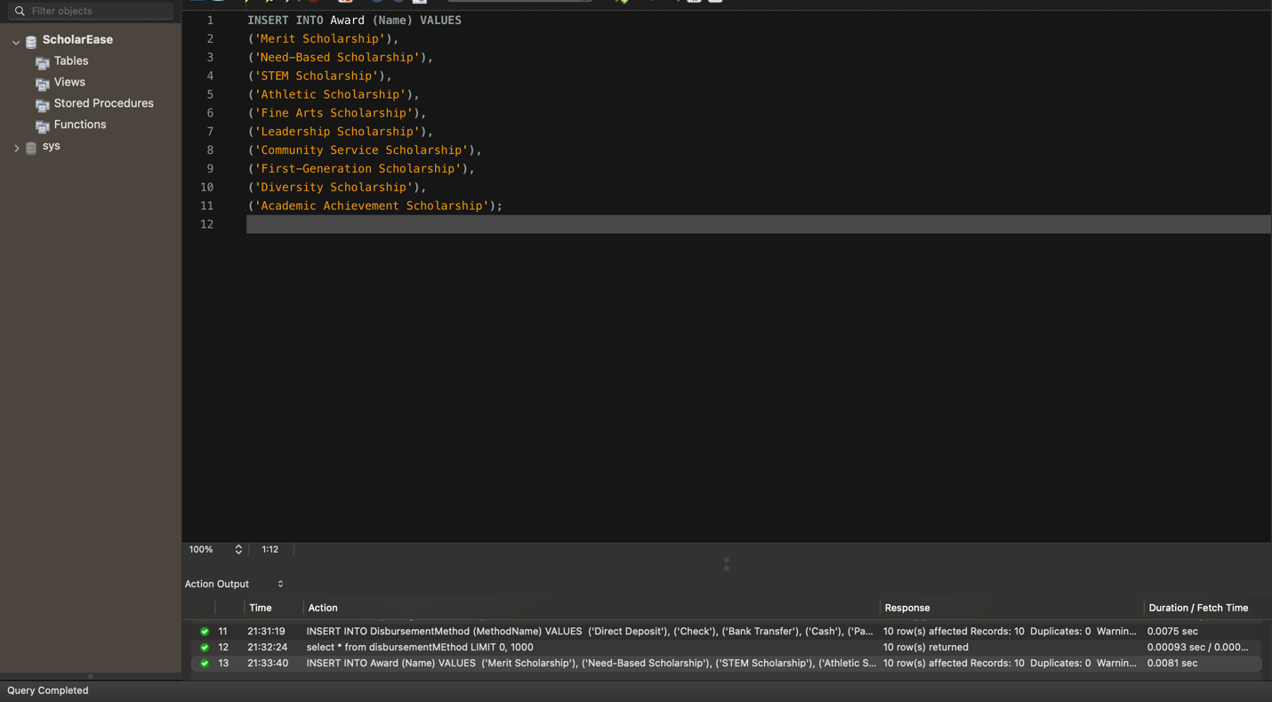

Displaying the data:

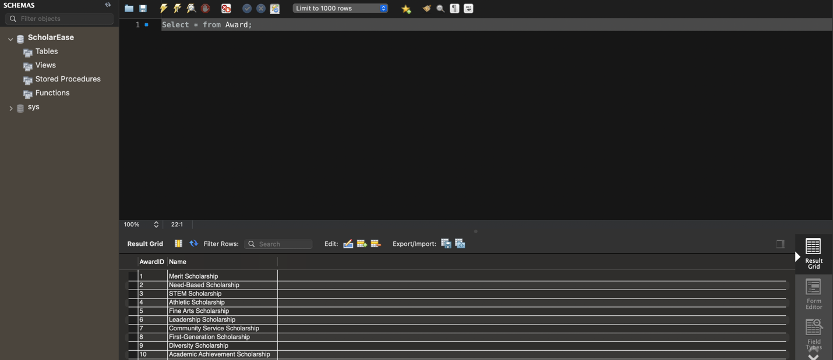

Institution Table:

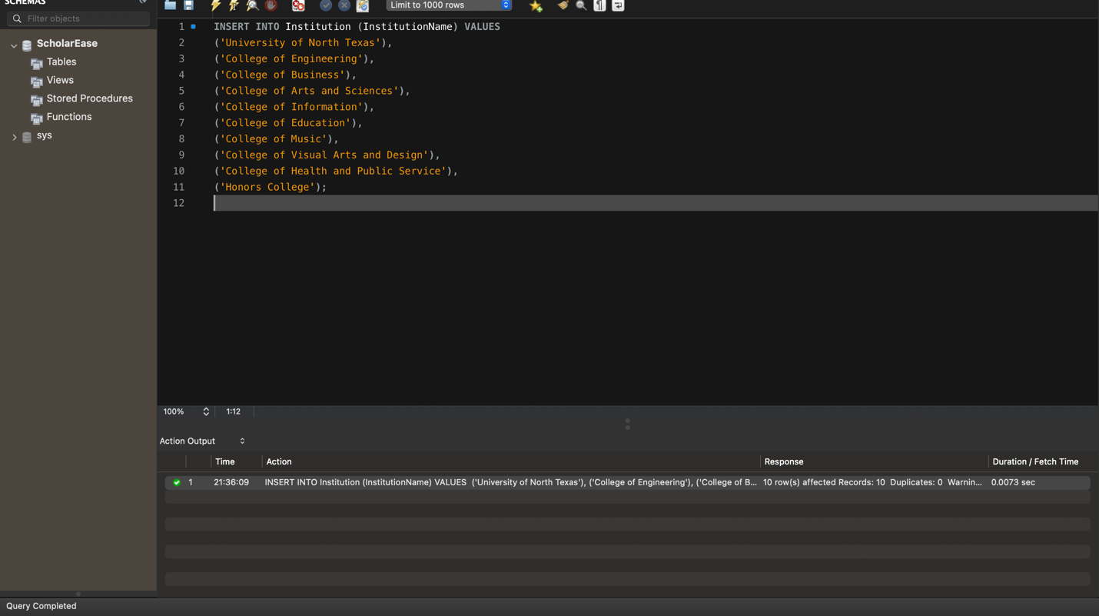

Displaying the data :

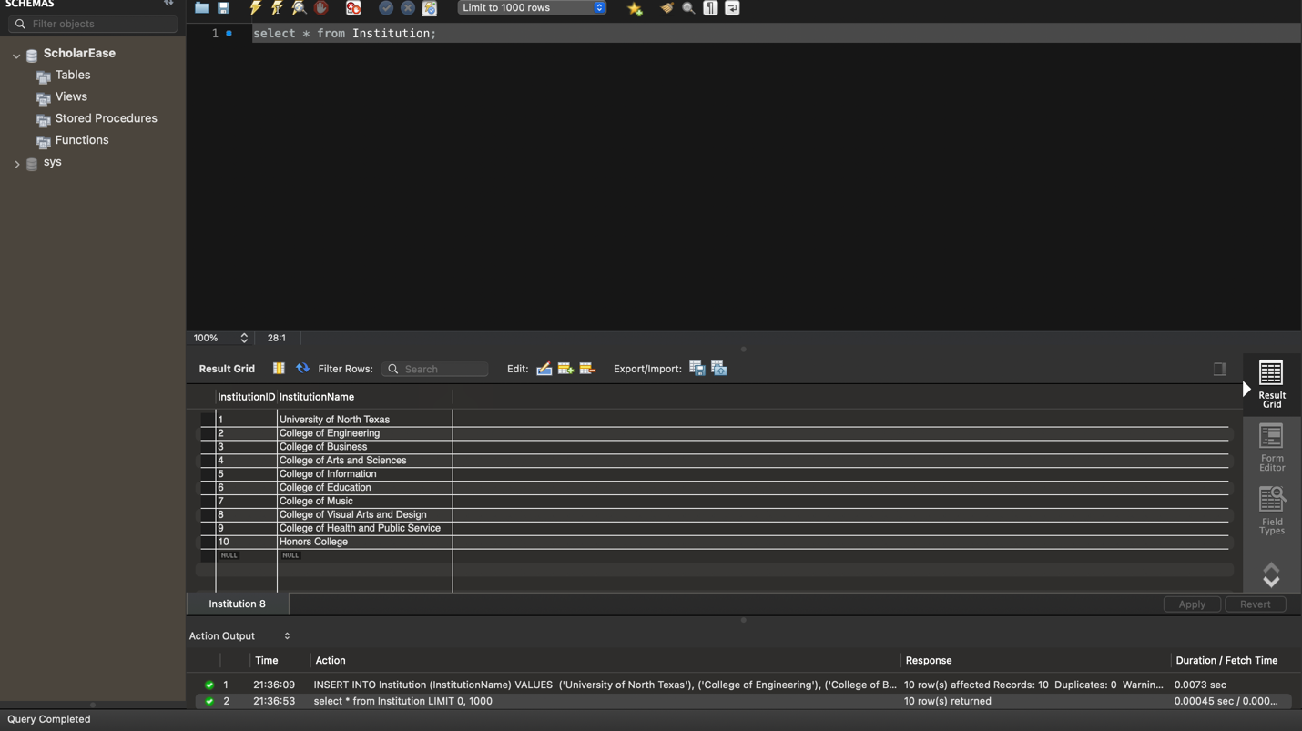

Student Table : INSERT INTO Student (StudentName, StudentAddress, StudentEmail, DepartmentID) VALUES

('John Doe', '123 Main St, Denton, TX', 'john.doe@myunt.com', 1),

('Jane Smith', '456 Elm St, Denton, TX', 'jane.smith@myunt.com', 2),

('Michael Johnson', '789 Oak St, Denton, TX', 'michael.johnson@myunt.com', 3),

('Emily Wilson', '101 Pine St, Denton, TX', 'emily.wilson@myunt.com', 4),

('Christopher Lee', '234 Maple St, Denton, TX', 'christopher.lee@myunt.com', 5),

('Sarah Brown', '567 Cedar St, Denton, TX', 'sarah.brown@myunt.com', 6),

('Daniel Taylor', '890 Birch St, Denton, TX', 'daniel.taylor@myunt.com', 7),

('Jessica Martinez', '111 Spruce St, Denton, TX', 'jessica.martinez@myunt.com', 8),

('Matthew Anderson', '222 Walnut St, Denton, TX', 'matthew.anderson@myunt.com', 9),

('Lauren Garcia', '333 Sycamore St, Denton, TX', 'lauren.garcia@myunt.com', 10),

('David Rodriguez', '444 Pine St, Denton, TX', 'david.rodriguez@myunt.com', 11),

('Ashley Nguyen', '555 Elm St, Denton, TX', 'ashley.nguyen@myunt.com', 12),

('Joshua Hernandez', '666 Maple St, Denton, TX', 'joshua.hernandez@myunt.com', 13),

('Amanda Chavez', '777 Oak St, Denton, TX', 'amanda.chavez@myunt.com', 14),

('Brandon Kim', '888 Cedar St, Denton, TX', 'brandon.kim@myunt.com', 15),

('Rachel Miller', '999 Birch St, Denton, TX', 'rachel.miller@myunt.com', 16),

('Erica Patel', '121 Spruce St, Denton, TX', 'erica.patel@myunt.com', 17),

('Kevin Wright', '232 Walnut St, Denton, TX', 'kevin.wright@myunt.com', 18),

('Olivia Torres', '343 Sycamore St, Denton, TX', 'olivia.torres@myunt.com', 19),

('Jason Clark', '454 Pine St, Denton, TX', 'jason.clark@myunt.com', 20),

('Stephanie Baker', '565 Elm St, Denton, TX', 'stephanie.baker@myunt.com', 1),

('Tyler Lewis', '676 Maple St, Denton, TX', 'tyler.lewis@myunt.com', 2),

('Hannah Scott', '787 Oak St, Denton, TX', 'hannah.scott@myunt.com', 3),

('Natalie Perez', '898 Cedar St, Denton, TX', 'natalie.perez@myunt.com', 4),

('Jacob Hall', '909 Birch St, Denton, TX', 'jacob.hall@myunt.com', 5),

('Samantha Young', '121 Spruce St, Denton, TX', 'samantha.young@myunt.com', 6),

('Ryan Allen', '232 Walnut St, Denton, TX', 'ryan.allen@myunt.com', 7),

('Kelsey White', '343 Sycamore St, Denton, TX', 'kelsey.white@myunt.com', 8),

('Nicole Martin', '454 Pine St, Denton, TX', 'nicole.martin@myunt.com', 9),

('Jordan Garcia', '565 Elm St, Denton, TX', 'jordan.garcia@myunt.com', 10);

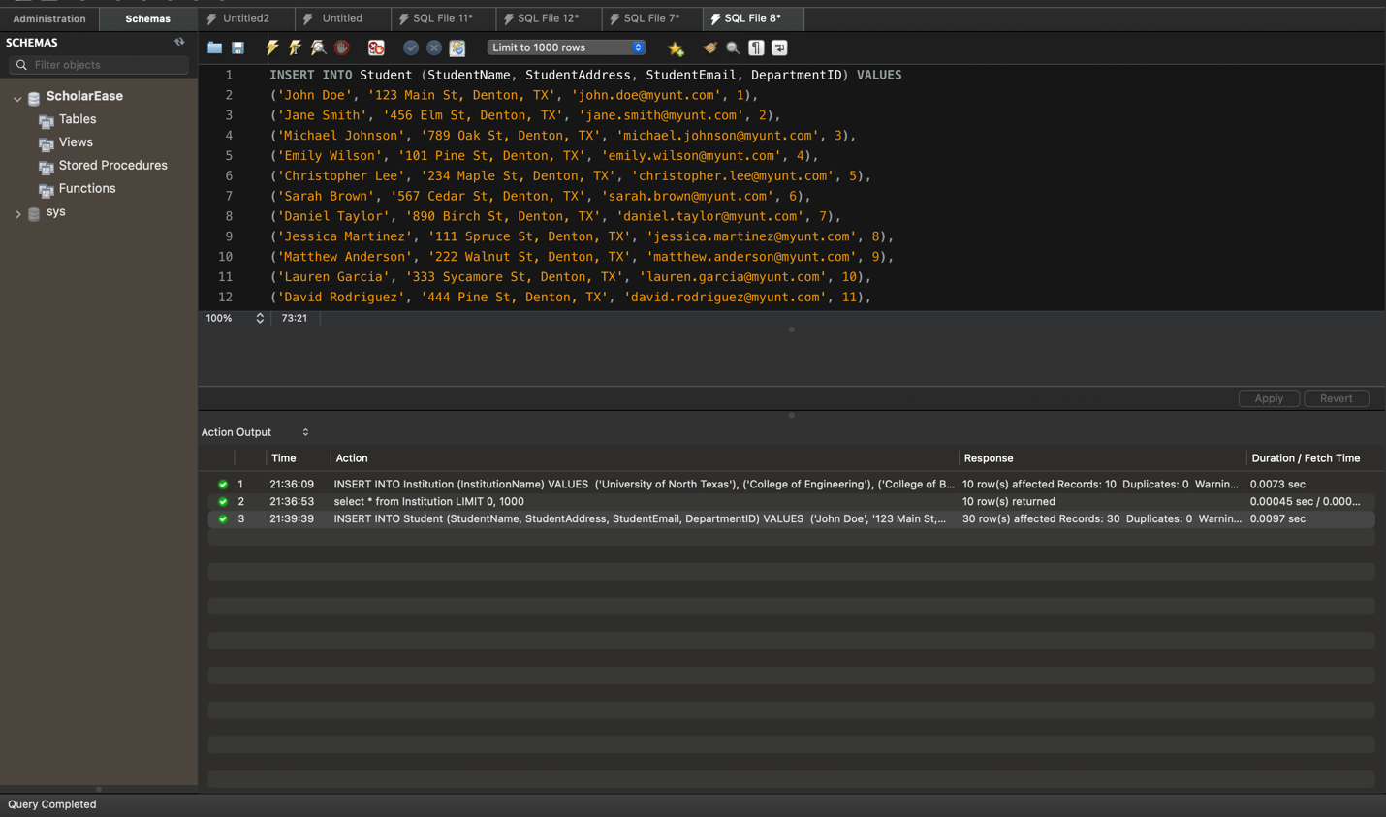

Result :

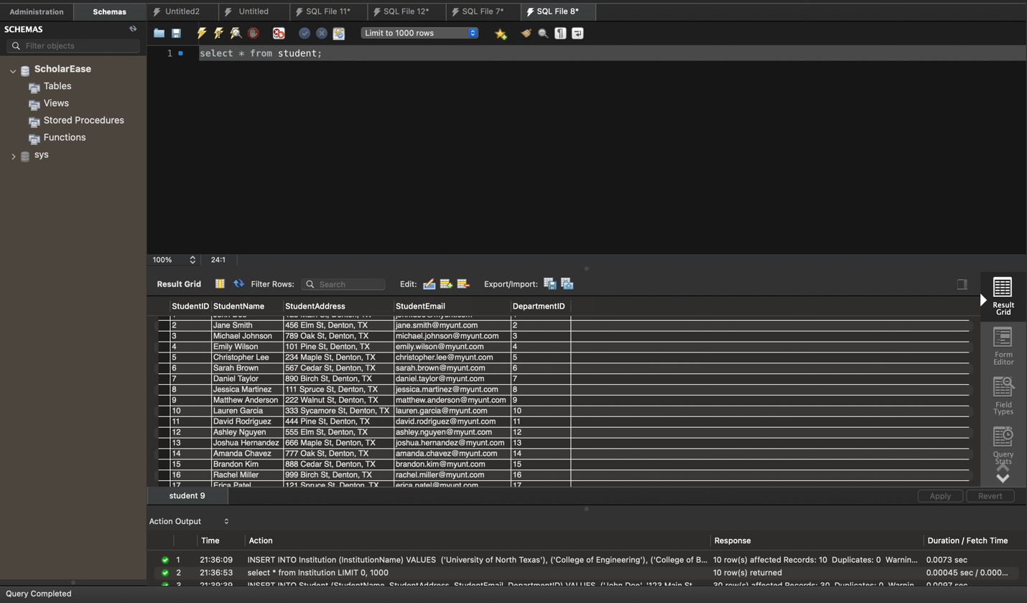

Scholarship Table: -- Insert data into Scholarship table

INSERT INTO Scholarship (AwardID, InstitutionID, Amount)

VALUES

(1, 1, 5000.00), -- Scholarship 1

(2, 2, 3000.00), -- Scholarship 2

(3, 1, 6000.00), -- Scholarship 3

(4, 4, 5500.00), -- Scholarship 4

(5, 3, 4000.00), -- Scholarship 5

(1, 5, 4500.00), -- Scholarship 6

(2, 1, 3200.00), -- Scholarship 7

(3, 2, 5800.00), -- Scholarship 8

(4, 3, 5200.00), -- Scholarship 9

(5, 4, 4300.00), -- Scholarship 10

(1, 2, 4700.00), -- Scholarship 11

(2, 3, 2900.00), -- Scholarship 12

(3, 4, 6100.00), -- Scholarship 13

(4, 1, 5400.00), -- Scholarship 14

(5, 5, 4200.00), -- Scholarship 15

(1, 4, 4800.00), -- Scholarship 16

(2, 5, 3100.00), -- Scholarship 17

(3, 3, 5900.00), -- Scholarship 18

(4, 2, 5300.00), -- Scholarship 19

(5, 1, 4100.00), -- Scholarship 20

(1, 3, 4600.00), -- Scholarship 21

(2, 4, 3300.00), -- Scholarship 22

(3, 5, 5700.00), -- Scholarship 23

(4, 1, 5600.00), -- Scholarship 24

(5, 2, 4400.00); -- Scholarship 25

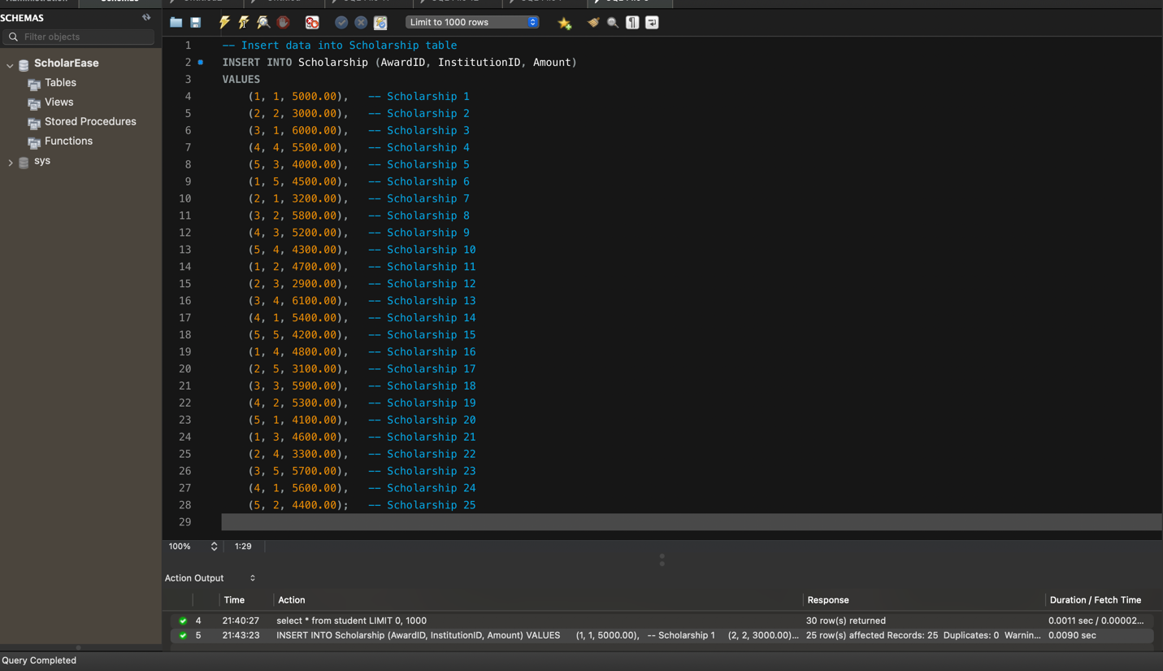

Displaying the data:

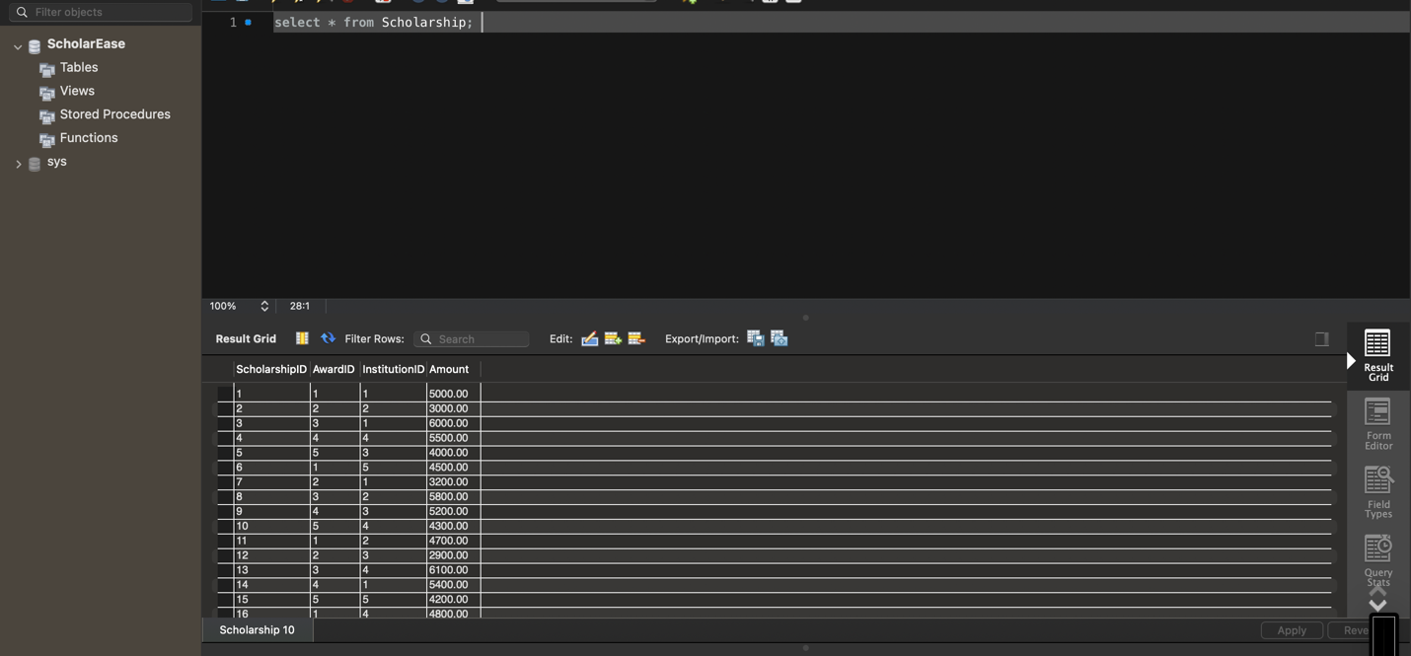

Application Table: -- Insert data into Application table

INSERT INTO Application (StudentID, ScholarshipID, ApplicationStatus)

VALUES

(1, 1, 'Pending'),

(2, 2, 'Approved'),

(3, 3, 'Rejected'),

(4, 4, 'Pending'),

(5, 5, 'Approved'),

(6, 6, 'Pending'),

(7, 7, 'Rejected'),

(8, 8, 'Pending'),

(9, 9, 'Approved'),

(10, 10, 'Rejected'),

(11, 11, 'Pending'),

(12, 12, 'Approved'),

(13, 13, 'Pending'),

(14, 14, 'Rejected'),

(15, 15, 'Pending'),

(16, 16, 'Approved'),

(17, 17, 'Pending'),

(18, 18, 'Rejected'),

(19, 19, 'Pending'),

(20, 20, 'Approved'),

(21, 21, 'Pending'),

(22, 22, 'Rejected'),

(23, 23, 'Pending'),

(24, 24, 'Approved'),

(25, 25, 'Pending');

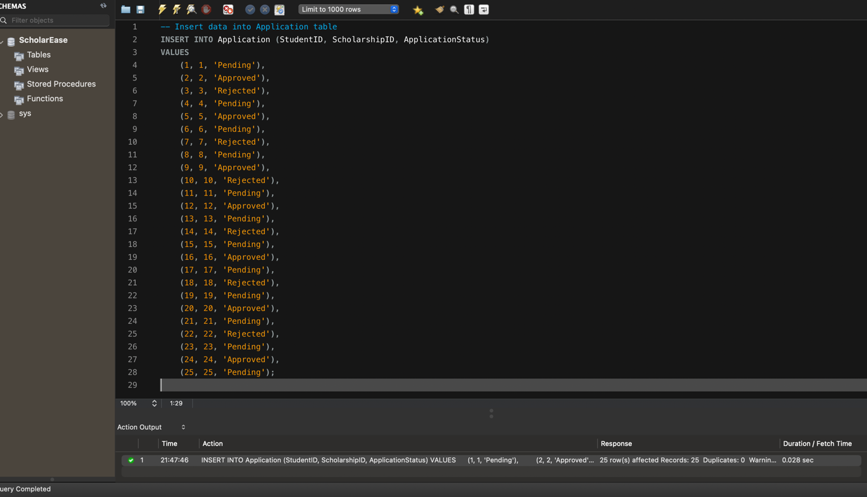

Displaying the data:

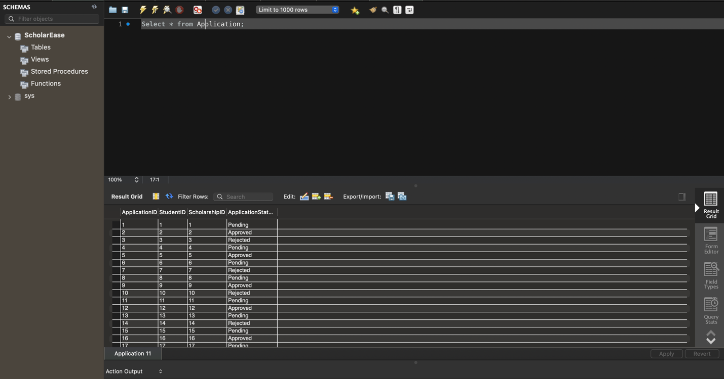

Criteria Table: -- Insert data into Criteria table

INSERT INTO Criteria (ScholarshipID, Description)

VALUES

(1, 'Must maintain a GPA of 3.5 or higher'),

(2, 'Active involvement in community service required'),

(3, 'Demonstrated financial need'),

(4, 'Leadership qualities and extracurricular activities preferred'),

(5, 'Essay submission required'),

(6, 'Must be pursuing a degree in STEM field'),

(7, 'Preference given to underrepresented minority students'),

(8, 'Demonstrated commitment to environmental conservation'),

(9, 'Strong academic record in relevant courses'),

(10, 'Demonstrated passion for social justice causes'),

(11, 'Exemplary performance in the arts'),

(12, 'Active participation in school sports'),

(13, 'Experience in entrepreneurship or innovation'),

(14, 'Preference given to first-generation college students'),

(15, 'Special consideration for students from rural areas'),

(16, 'Demonstrated proficiency in a foreign language'),

(17, 'Research experience in the chosen field of study'),

(18, 'Internship or work experience in related industry'),

(19, 'Leadership roles in student organizations'),

(20, 'Published academic or research papers'),

(21, 'Participation in specialized training programs'),

(22, 'Volunteer work with marginalized communities'),

(23, 'Innovative solutions to community challenges'),

(24, 'Demonstrated ability to overcome adversity'),

(25, 'Invention or patent in relevant field');

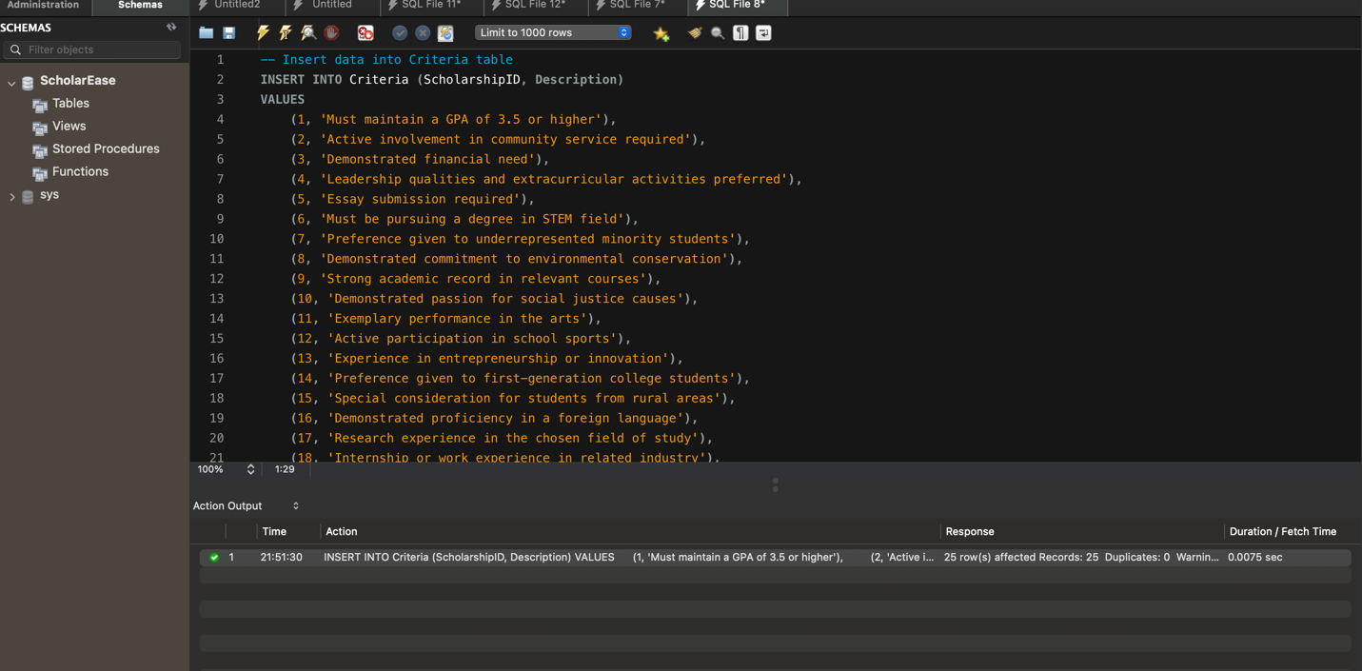

Displaying the result:

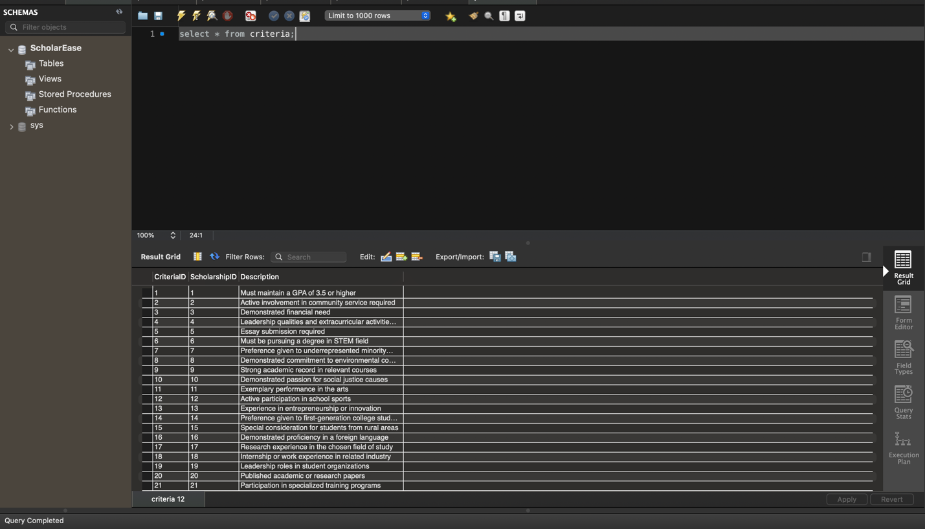

Review Table : -- Insert data into Review table

INSERT INTO Review (ScholarshipID, ApplicationID, ReviewerID, ReportID, Status)

VALUES

(1, 1, 1, 1, 'Pending'),

(2, 2, 2, 2, 'Approved'),

(3, 3, 3, 3, 'Rejected'),

(4, 4, 4, 4, 'Pending'),

(5, 5, 5, 5, 'Approved'),

(6, 6, 6, 6, 'Pending'),

(7, 7, 7, 7, 'Rejected'),

(8, 8, 8, 8, 'Pending'),

(9, 9, 9, 9, 'Approved'),

(10, 10, 10, 10, 'Rejected'),

(11, 11, 11, 11, 'Pending'),

(12, 12, 12, 12, 'Approved'),

(13, 13, 13, 13, 'Pending'),

(14, 14, 14, 14, 'Rejected'),

(15, 15, 15, 15, 'Pending'),

(16, 16, 16, 16, 'Approved'),

(17, 17, 17, 17, 'Pending'),

(18, 18, 18, 18, 'Rejected'),

(19, 19, 19, 19, 'Pending'),

(20, 20, 20, 20, 'Approved'),

(21, 21, 21, 21, 'Pending'),

(22, 22, 22, 22, 'Rejected'),

(23, 23, 23, 23, 'Pending'),

(24, 24, 24, 24, 'Approved'),

(25, 25, 25, 25, 'Pending'); 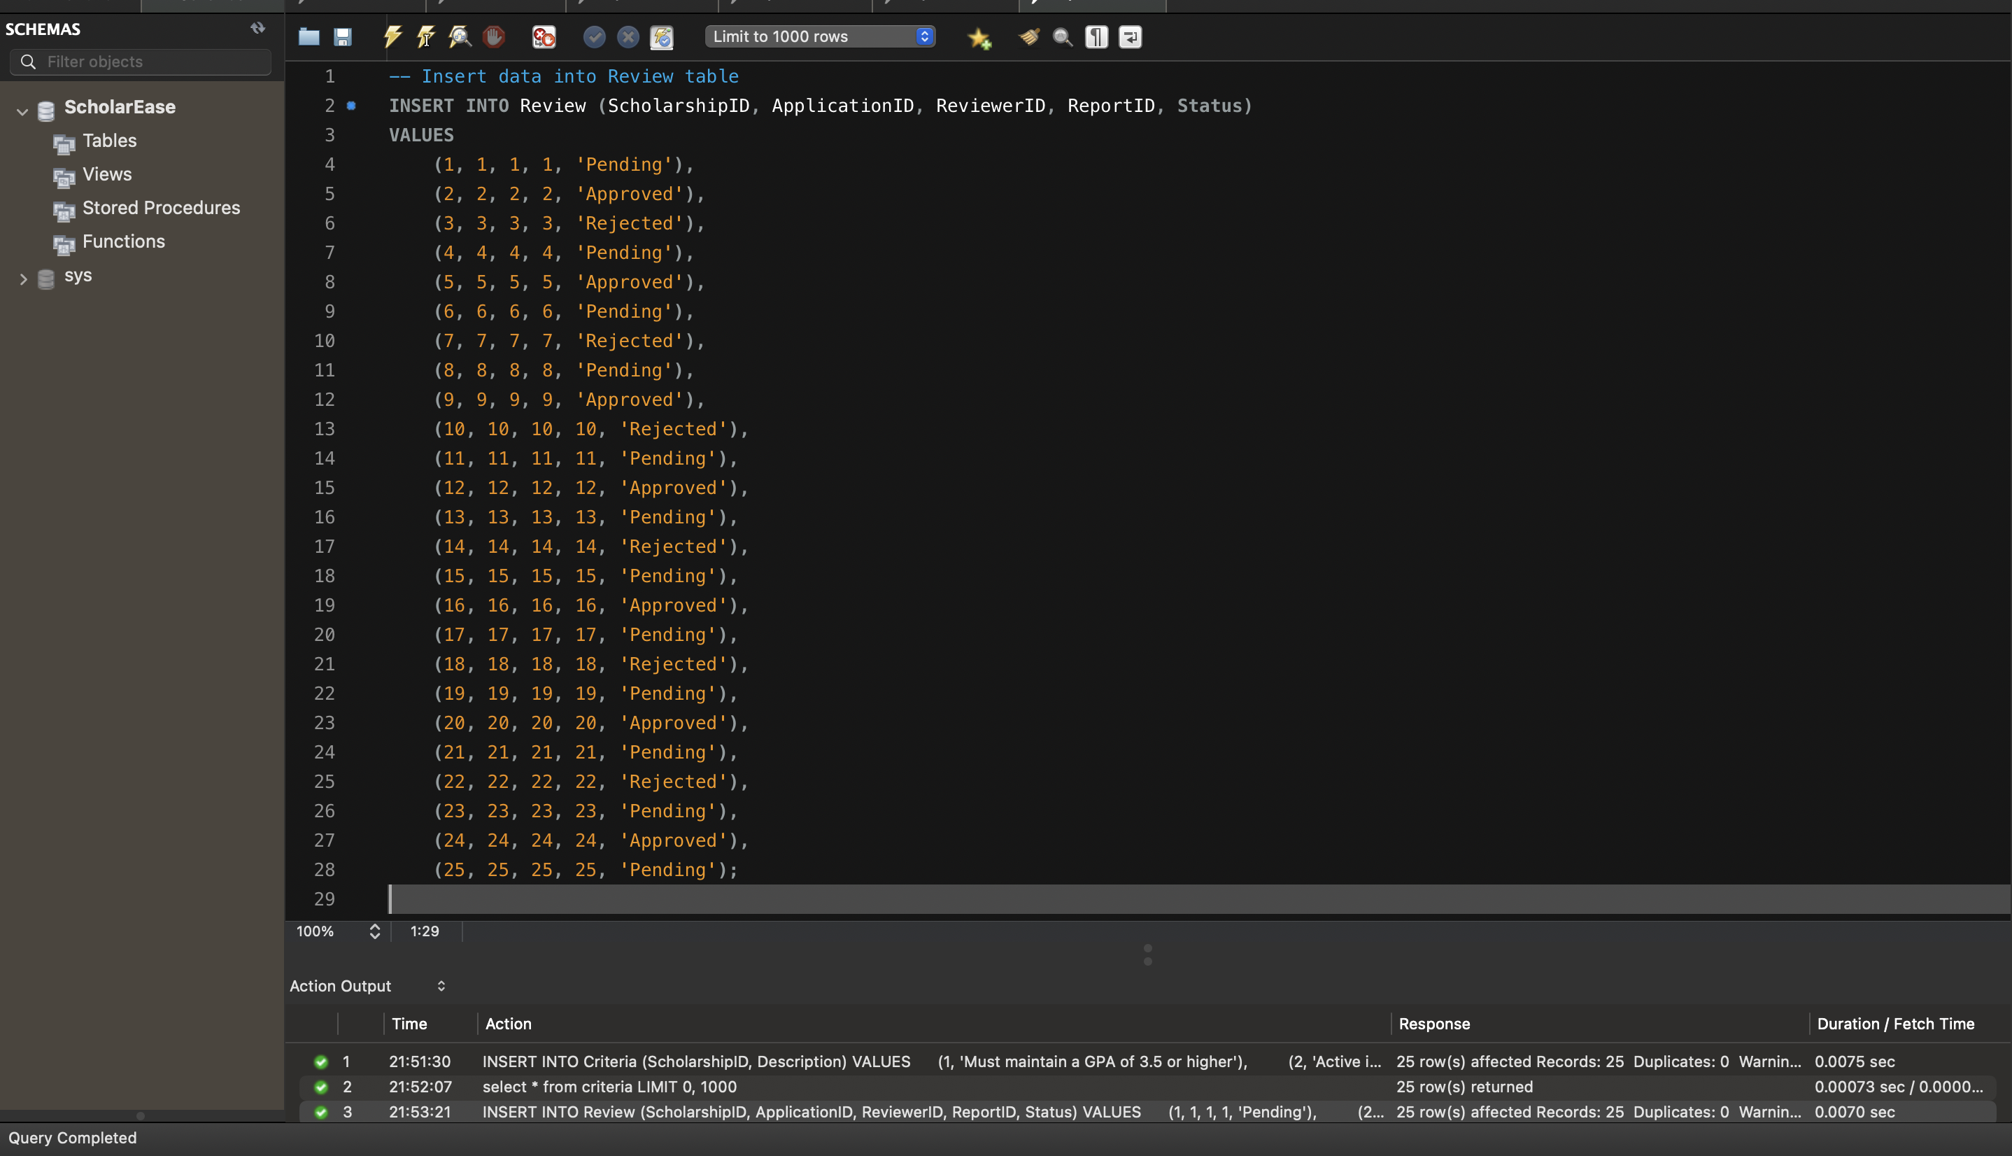

Displaying the result: 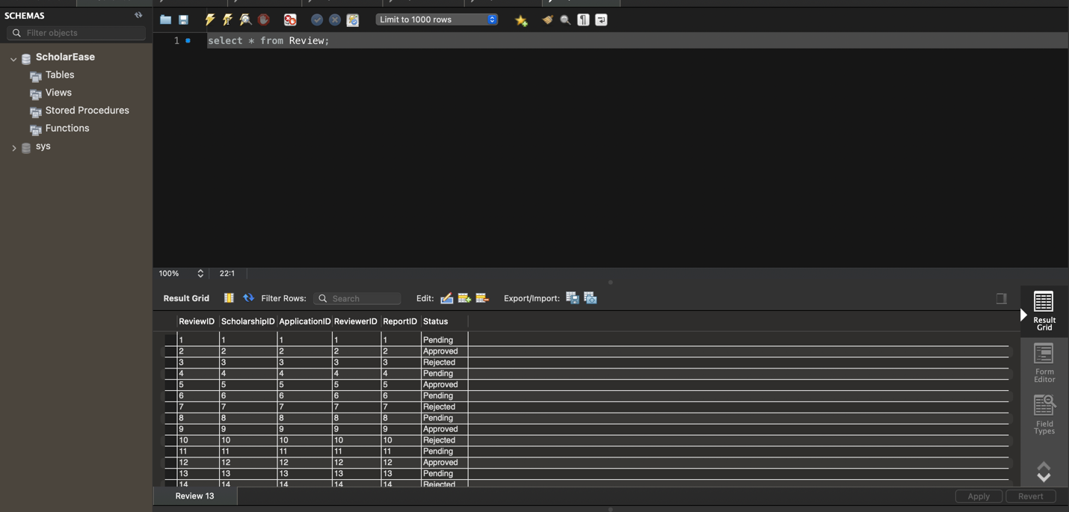

Disbursement Table:

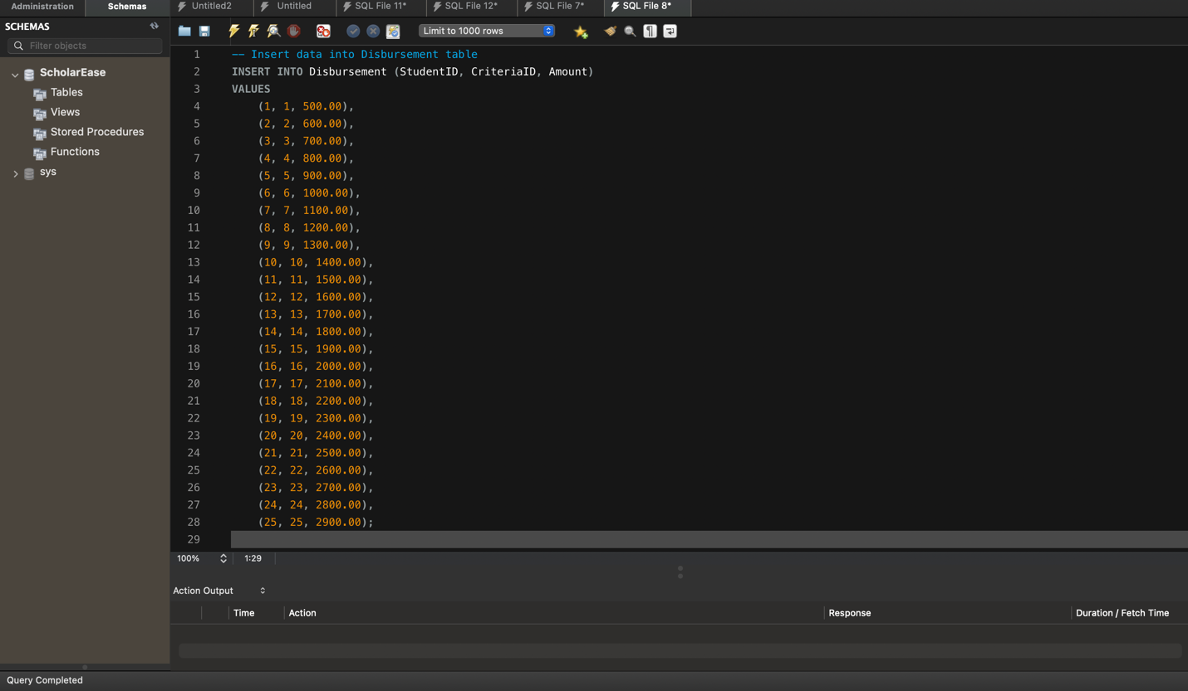

Displying the data : 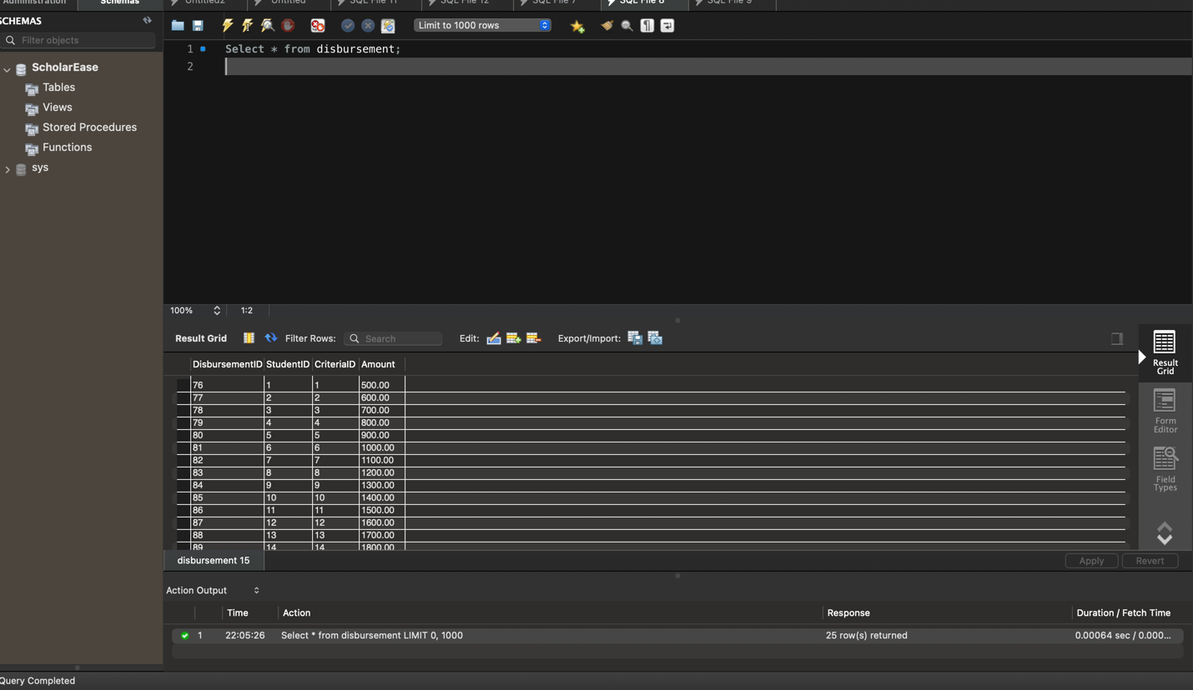

QUERIES/ DATA ANALYSIS Reports:

1) How many applications were approved/rejected for in each department

SELECT

d.DepartmentName,

SUM(CASE WHEN a.ApplicationStatus = 'Approved' THEN 1 ELSE 0 END) AS ApprovedApplications,

SUM(CASE WHEN a.ApplicationStatus = 'Rejected' THEN 1 ELSE 0 END) AS RejectedApplications

FROM

Department d

LEFT JOIN

Student s ON d.DepartmentID = s.DepartmentID

LEFT JOIN

Application a ON s.StudentID = a.StudentID

GROUP BY d.DepartmentName;

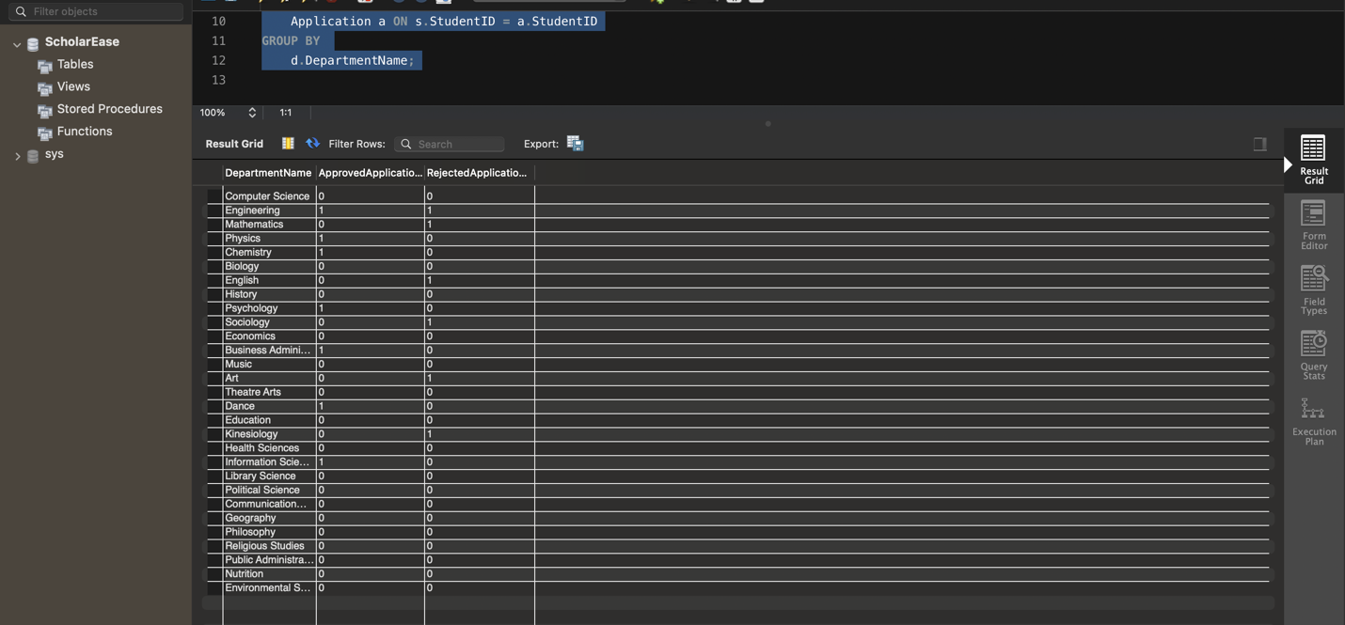

2. Write a SQL query to calculate the total disbursement amount for each department by summing the disbursement amounts associated with students in each department..

**QUERY :** WITH TotalDisbursementPerDepartment AS (

SELECT

s.DepartmentID,

d.DepartmentName,

SUM(db.Amount) AS TotalDisbursement

FROM

Disbursement db

INNER JOIN

Student s ON db.StudentID = s.StudentID

INNER JOIN

Department d ON s.DepartmentID = d.DepartmentID

GROUP BY

s.DepartmentID

)

SELECT

DepartmentName,

TotalDisbursement

FROM

TotalDisbursementPerDepartment

ORDER BY

DepartmentName;

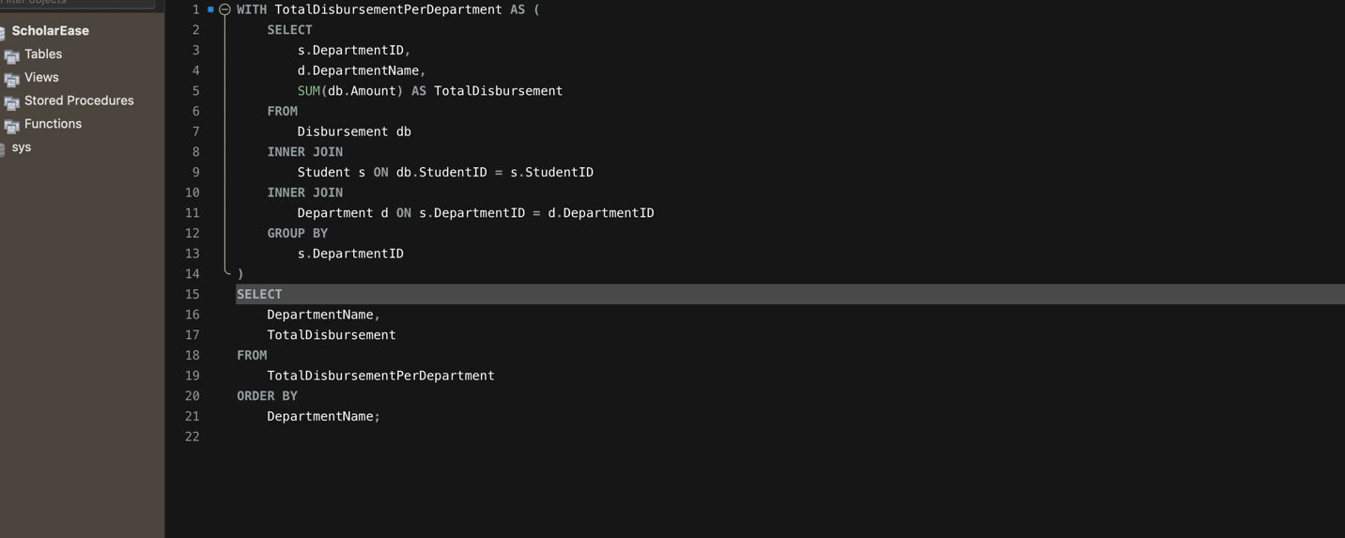

Result:

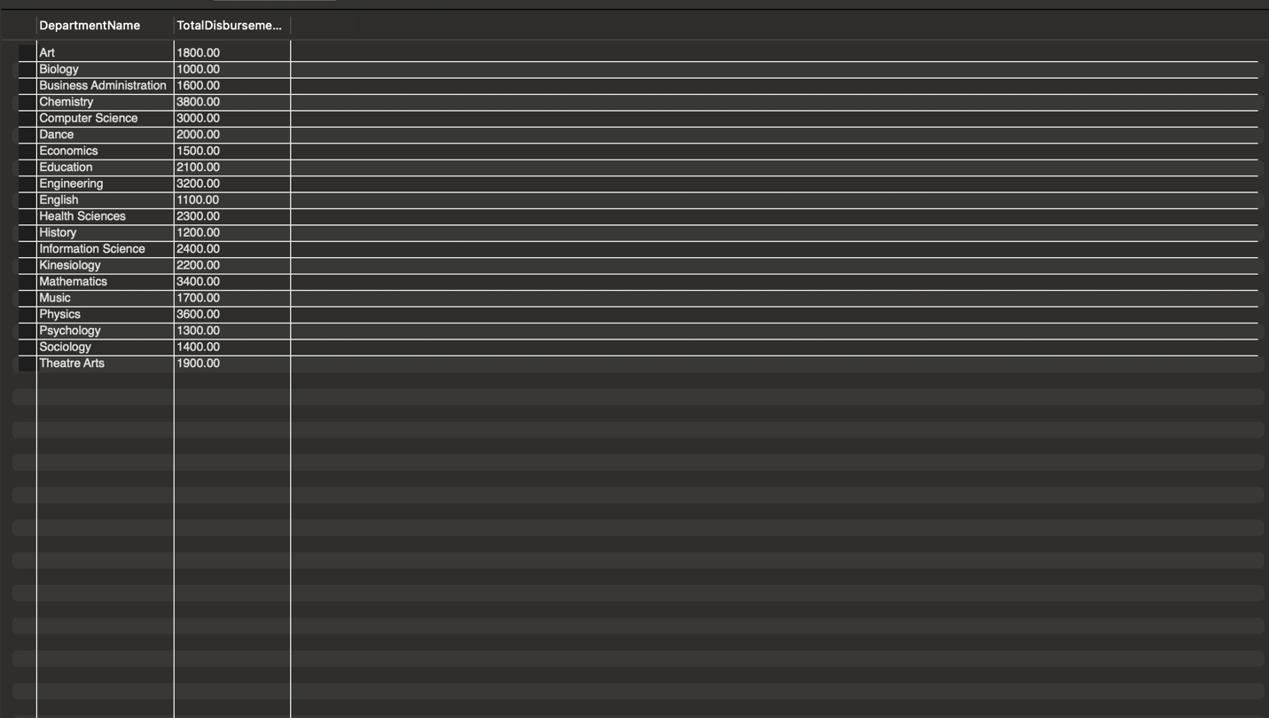

3)   
Write a query to retrieve the student name, department name, and scholarship criteria for each student who has applied for a scholarship. Ensure that only non-null scholarship criteria are included in the result set, and then order the results by student name.

Query: WITH StudentScholarshipCriteria AS (

SELECT

s.StudentName,

d.DepartmentName,

c.Description AS ScholarshipCriteria

FROM

Student s

INNER JOIN

Department d ON s.DepartmentID = d.DepartmentID

LEFT JOIN

Application a ON s.StudentID = a.StudentID

LEFT JOIN

Scholarship sch ON a.ScholarshipID = sch.ScholarshipID

LEFT JOIN

Criteria c ON sch.ScholarshipID = c.ScholarshipID

)

SELECT

StudentName,

DepartmentName,

ScholarshipCriteria

FROM StudentScholarshipCriteria

WHERE ScholarshipCriteria IS NOT NULL -- Exclude rows where ScholarshipCriteria is null

ORDER BY StudentName;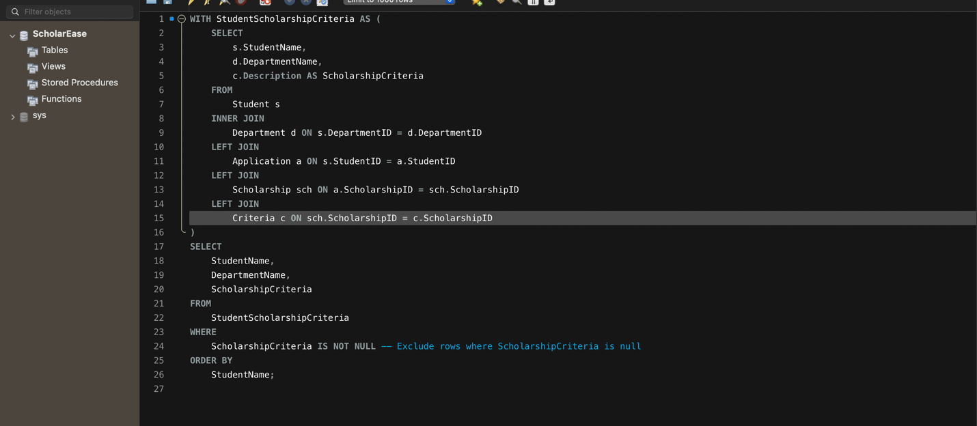

Result :

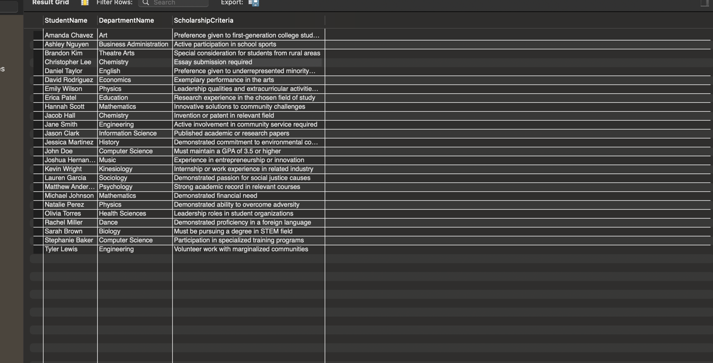

4. Write a query to retrieve information about students, including their name, email, department, latest application status, scholarship criteria, total amount disbursed, and total number of reviewed applications. Include students whose latest application status is 'Approved' or if they don't have any applications. Additionally, filter out students with a total amount disbursed greater than 1000. Finally, order the results by student ID.

Query : WITH RankedStudents AS (

SELECT

s.StudentID,

s.StudentName,

s.StudentEmail,

d.DepartmentName,

a.ApplicationStatus,

ROW_NUMBER() OVER (PARTITION BY s.StudentID ORDER BY a.ApplicationID DESC) AS RowNum

FROM

Student s

LEFT JOIN

Application a ON s.StudentID = a.StudentID

LEFT JOIN

Department d ON s.DepartmentID = d.DepartmentID

),

TotalDisbursement AS (

SELECT

s.StudentID,

SUM(d.Amount) AS TotalAmountDisbursed

FROM

Student s

LEFT JOIN

Disbursement d ON s.StudentID = d.StudentID

GROUP BY

s.StudentID

),

ReviewedApplications AS (

SELECT

StudentID,

COUNT(*) AS TotalReviewedApplications

FROM

Application a

INNER JOIN

Review r ON a.ApplicationID = r.ApplicationID

GROUP BY

StudentID

),

StudentScholarshipCriteria AS (

SELECT

s.StudentName,

d.DepartmentName,

c.Description AS ScholarshipCriteria

FROM

Student s

INNER JOIN

Department d ON s.DepartmentID = d.DepartmentID

LEFT JOIN

Application a ON s.StudentID = a.StudentID

LEFT JOIN

Criteria c ON a.ScholarshipID = c.ScholarshipID

)

SELECT

rs.StudentID,

rs.StudentName,

rs.StudentEmail,

rs.DepartmentName,

rs.ApplicationStatus,

ssc.ScholarshipCriteria,

COALESCE(td.TotalAmountDisbursed, 0) AS TotalAmountDisbursed,

COALESCE(ra.TotalReviewedApplications, 0) AS TotalReviewedApplications

FROM

RankedStudents rs

LEFT JOIN

StudentScholarshipCriteria ssc ON rs.StudentName = ssc.StudentName

LEFT JOIN

TotalDisbursement td ON rs.StudentID = td.StudentID

LEFT JOIN

ReviewedApplications ra ON rs.StudentID = ra.StudentID

WHERE

rs.RowNum = 1

AND (rs.ApplicationStatus = 'Approved' OR rs.ApplicationStatus IS NULL)

AND td.TotalAmountDisbursed > 1000

ORDER BY

rs.StudentID;

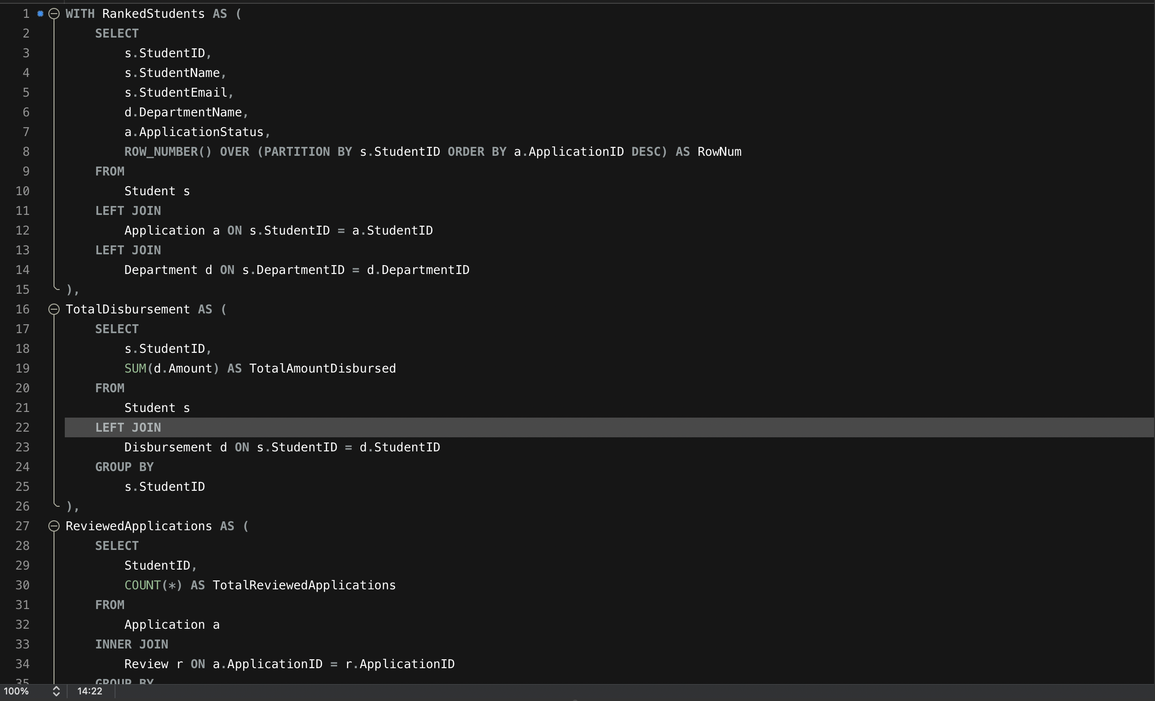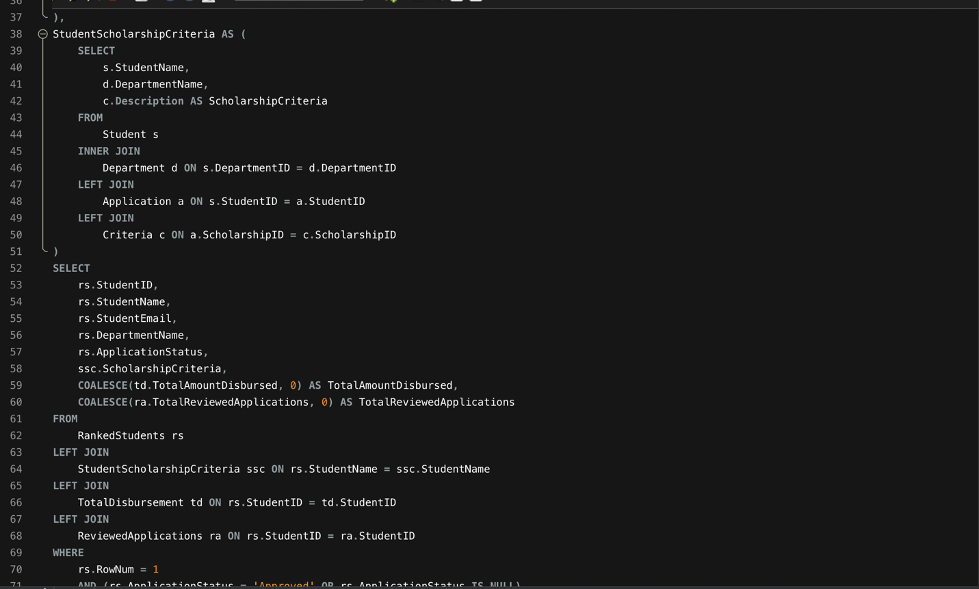

Result:

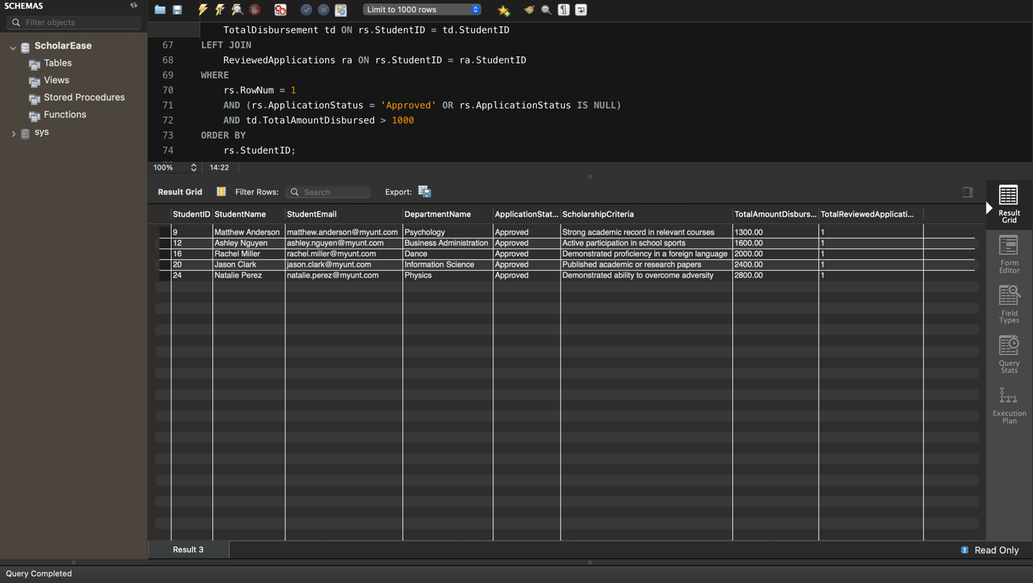

5. Write a query to retrieve information about scholarships along with the names of students who have applied for them, their application statuses, and the departments they belong to. Include only those scholarships that have received applications and sort the results by scholarship name.

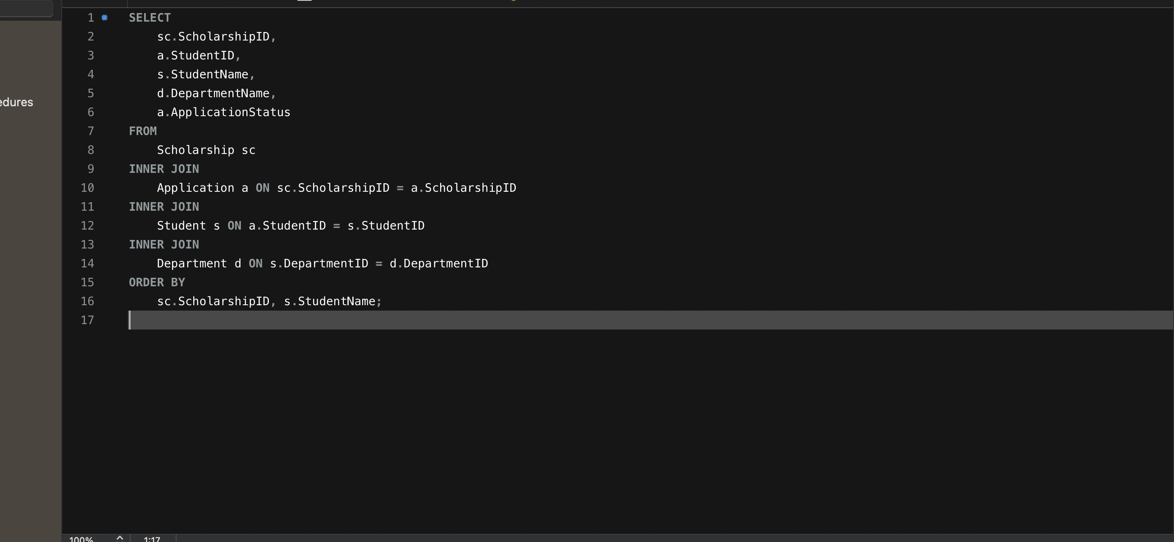

Result : 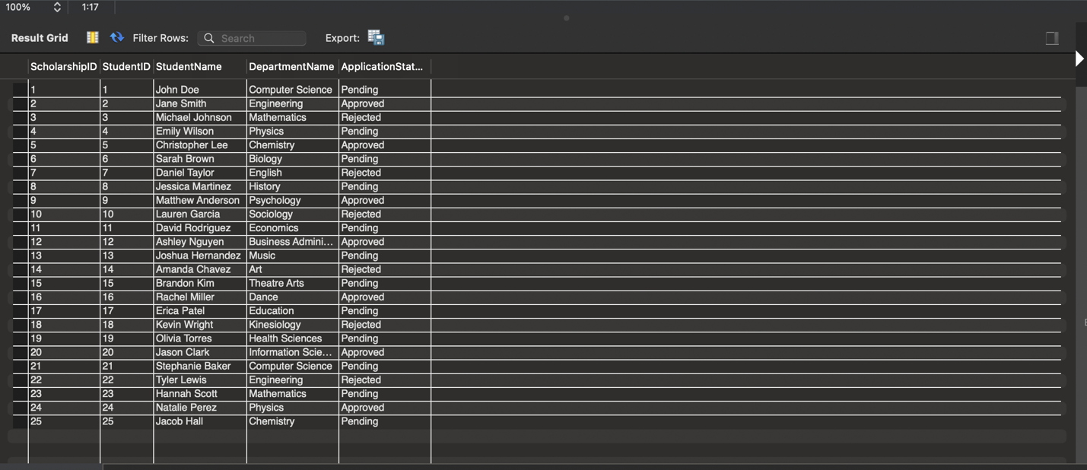

6: Write a SQL query to retrieve information about ranked students, including their student ID, name, email, department, latest application status, scholarship criteria, total amount disbursed, and total number of reviewed applications. Ensure that the results only include non-null values for each attribute and are ordered by student ID."

With RankedStudents AS (

SELECT

s.StudentID,

s.StudentName,

s.StudentEmail,

d.DepartmentName,

a.ApplicationStatus,

ROW_NUMBER() OVER (PARTITION BY s.StudentID ORDER BY a.ApplicationID DESC) AS RowNum

FROM

Student s

LEFT JOIN

Application a ON s.StudentID = a.StudentID

LEFT JOIN

Department d ON s.DepartmentID = d.DepartmentID

), TotalDisbursement AS (

SELECT

s.StudentID,

SUM(d.Amount) AS TotalAmountDisbursed

FROM

Student s

LEFT JOIN

Disbursement d ON s.StudentID = d.StudentID

GROUP BY

s.StudentID

), ReviewedApplications AS (

SELECT

a.StudentID,

COUNT(*) AS TotalReviewedApplications

FROM

Application a

INNER JOIN

Review r ON a.ApplicationID = r.ApplicationID

GROUP BY

a.StudentID

), StudentScholarshipCriteria AS (

SELECT

s.StudentName,

d.DepartmentName,

c.Description AS ScholarshipCriteria

FROM

Student s

INNER JOIN

Department d ON s.DepartmentID = d.DepartmentID

LEFT JOIN

Application a ON s.StudentID = a.StudentID

LEFT JOIN

Criteria c ON a.ScholarshipID = c.ScholarshipID

)

SELECT

rs.StudentID,

rs.StudentName,

rs.StudentEmail,

rs.DepartmentName,

rs.ApplicationStatus,

ssc.ScholarshipCriteria,

COALESCE(td.TotalAmountDisbursed, 0) AS TotalAmountDisbursed,

COALESCE(ra.TotalReviewedApplications, 0) AS TotalReviewedApplications

FROM

RankedStudents rs

LEFT JOIN

StudentScholarshipCriteria ssc ON rs.StudentName = ssc.StudentName

LEFT JOIN

TotalDisbursement td ON rs.StudentID = td.StudentID

LEFT JOIN

ReviewedApplications ra ON rs.StudentID = ra.StudentID

WHERE

rs.RowNum = 1

AND rs.StudentName IS NOT NULL

AND rs.StudentEmail IS NOT NULL

AND rs.DepartmentName IS NOT NULL

AND rs.ApplicationStatus IS NOT NULL

AND ssc.ScholarshipCriteria IS NOT NULL

AND td.TotalAmountDisbursed IS NOT NULL

AND ra.TotalReviewedApplications IS NOT NULL

ORDER BY

rs.StudentID;

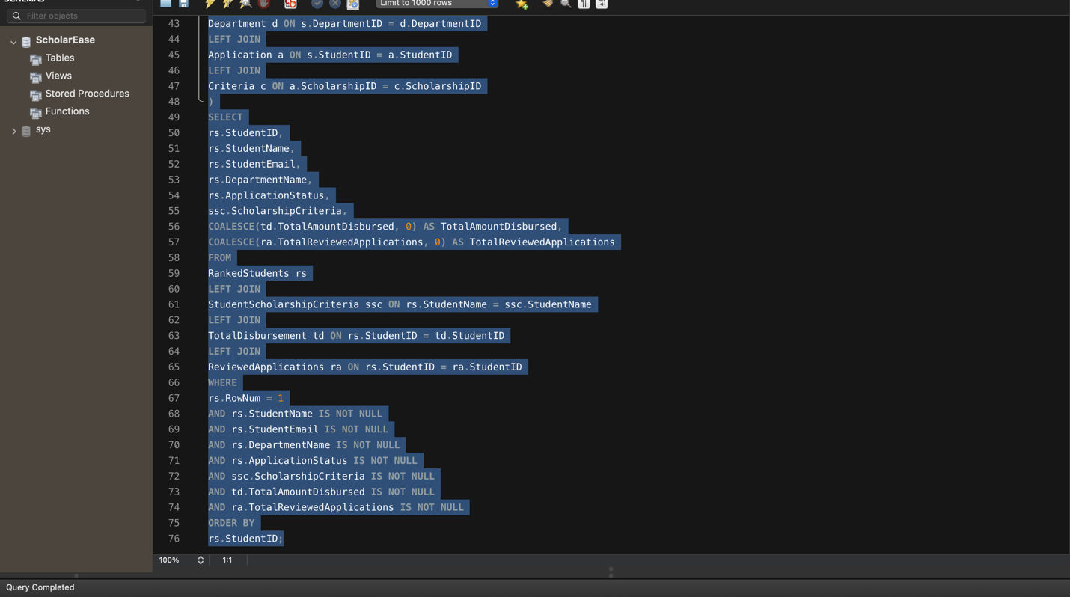

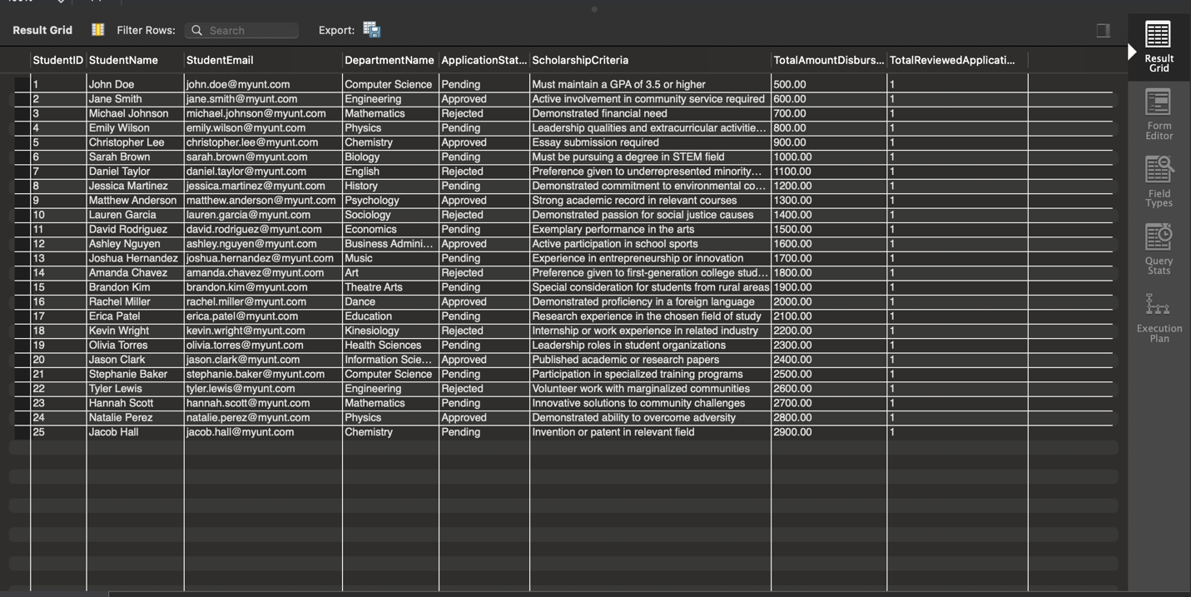

7. Write a SQL query to retrieve the top 3 criteria that have the highest total scholarship amount disbursed.

WITH CriteriaTotalDisbursement AS (

SELECT

c.CriteriaID,

c.Description AS CriteriaDescription,

SUM(s.Amount) AS TotalDisbursedAmount

FROM

Criteria c

INNER JOIN

Scholarship s ON c.ScholarshipID = s.ScholarshipID

GROUP BY

c.CriteriaID, c.Description

)

SELECT

CriteriaID,

CriteriaDescription,

TotalDisbursedAmount

FROM

CriteriaTotalDisbursement

ORDER BY

TotalDisbursedAmount DESC

LIMIT 3;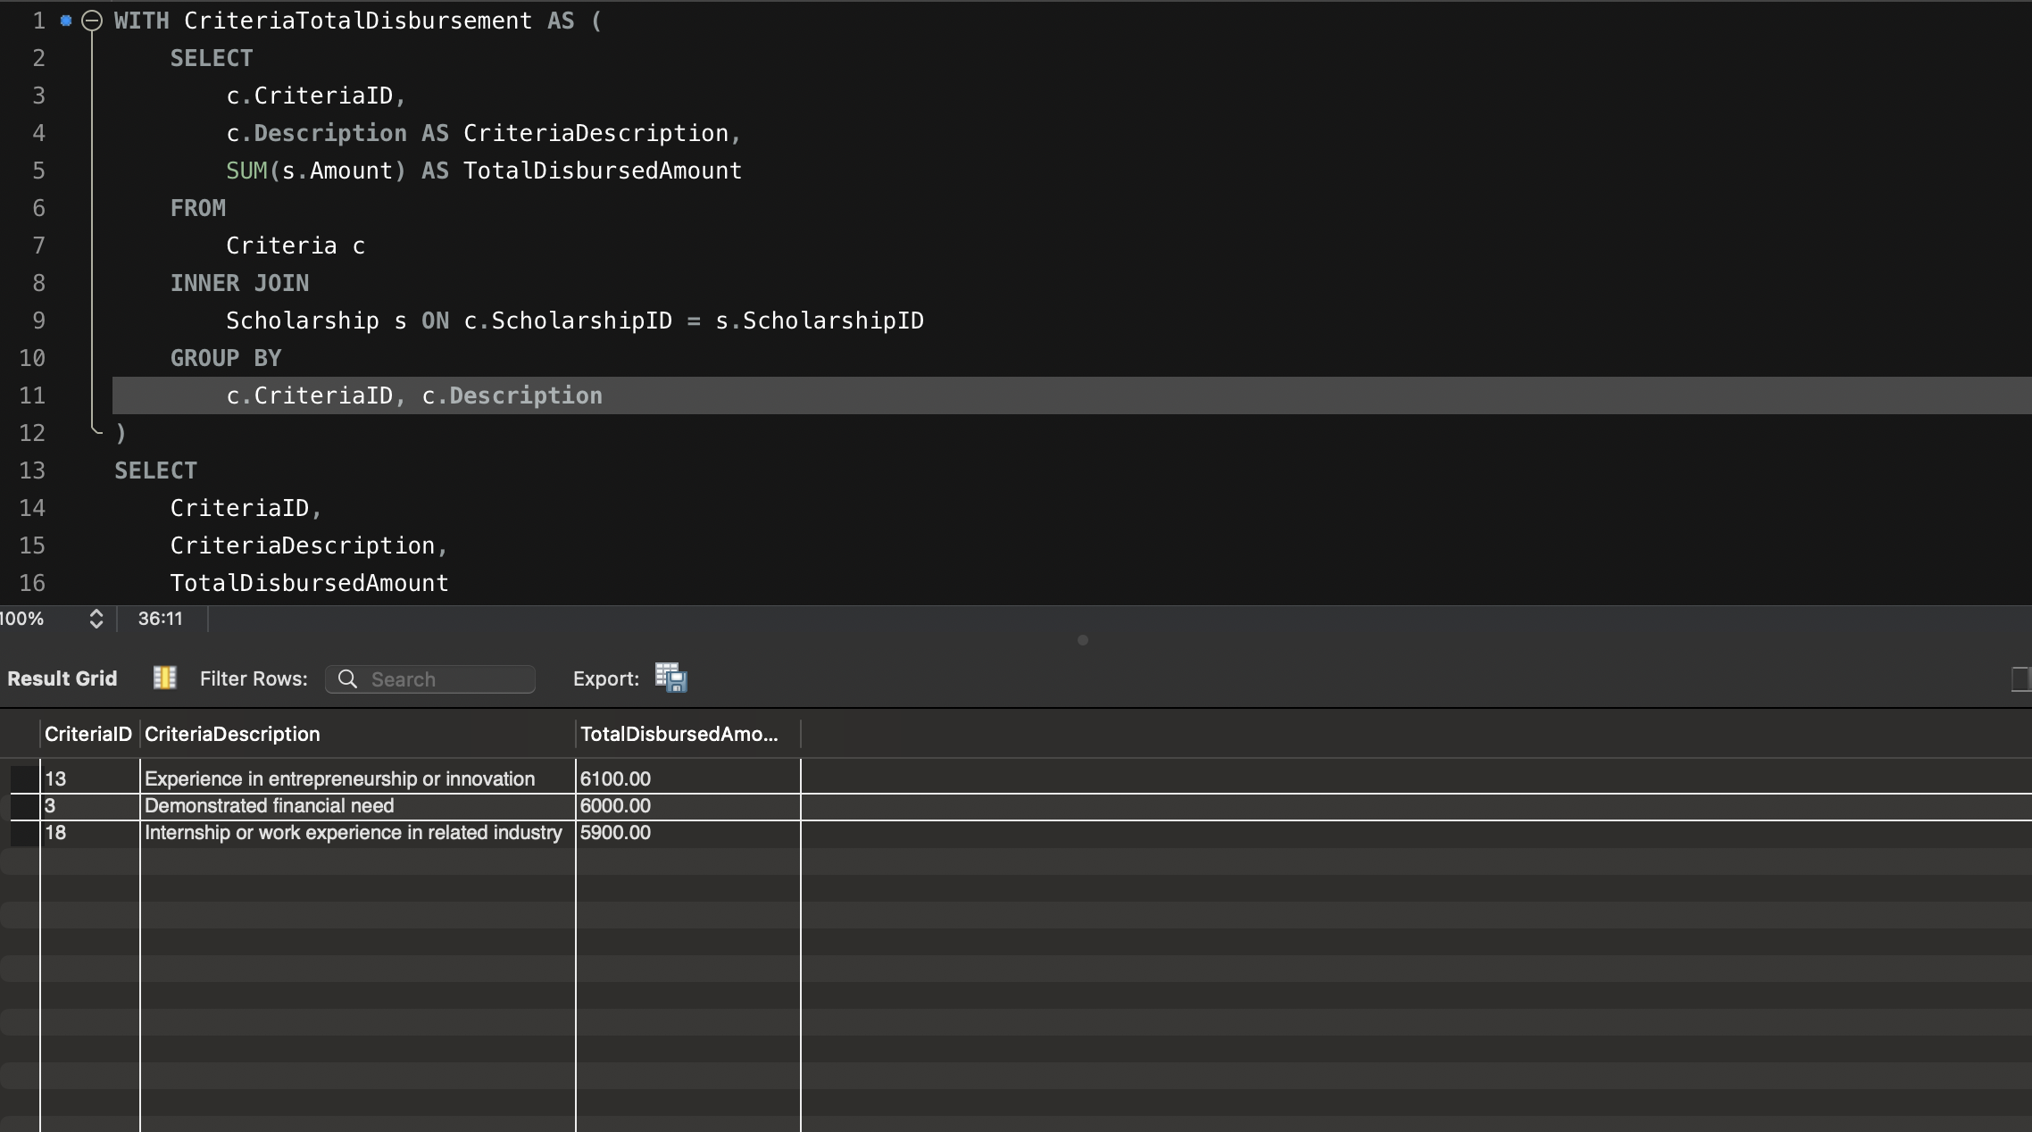

8. Write a SQL query to retriveve the students who have been awarded scholarships from the Biology and Computer Sciences departments